# Java并发编程的艺术

# Jave并发编程基础

## 4.2 启动和终止线程

### 4.2.3 理解中断

中断可以理解为线程的一个标识位属性，表示一个运行中的线程是否被其他线程进行中断操作。其他线程调用interrupt()方法对其进行中断

线程通过检查自身是否被中断进行响应，线程通过方法isInterrupted()来进行判断是否被中断，也可以调用静态方法Thread.interrupted（）对当前线程的中断标识位进行复位。如果该线程已经处于终结状态，即是该线程被中断过，在调用该线程对象isInterruoted()时依旧会返回false。

许多声明抛出InterruptedException的方法，在抛出InterruptedException之前，Java虚拟机会将该线程的中断标识位清楚，然后抛出InteruptedExcetion，此时调用isInterrupted()方法将会返回false；

interrupt():其作用是中断此线程（此线程不一定是当前线程，而是指调用该方法的Thread实例所代表的线程），但实际上只是给线程设置一个中断标志，线程仍会继续运行

interrupted()方法：测试当前线程是否被中断，返回一个boolean并清楚中断状态，第二次再调用时中断状态已经被清楚，将返回一个false。

isInterrupted()方法：作用是只测试此线程是否被中断，不清楚中断状态。

interrupt（）是给线程设置中断标志；interrupted（）是检测中断并清除中断状态；isInterrupted（）只检测中断。还有重要的一点就是interrupted（）作用于当前线程，interrupt（）和isInterrupted（）作用于此线程，即代码中调用此方法的实例所代表的线程

# Java中的锁

## 5.2 对列同步器

AbstractQueueSynchronizer，用来构建锁或者其他同步组件的基础框架，使用一个int成员变量表示同步状态，通过内置的FIFO对列来完成资源获取线程排对工作。

同步器既可以支持独占式地获取同步状态，也可以支持共享式的获取同步状态，这样就可以方便实现不同类型的同步组件(ReentrantLock，ReentrantReadWriteLock和CountDownLatch等)

同步器功能：同步状态管理，线程排对，等待与唤醒等底层操作。

### 5.2.1 同步对列的接口与示例

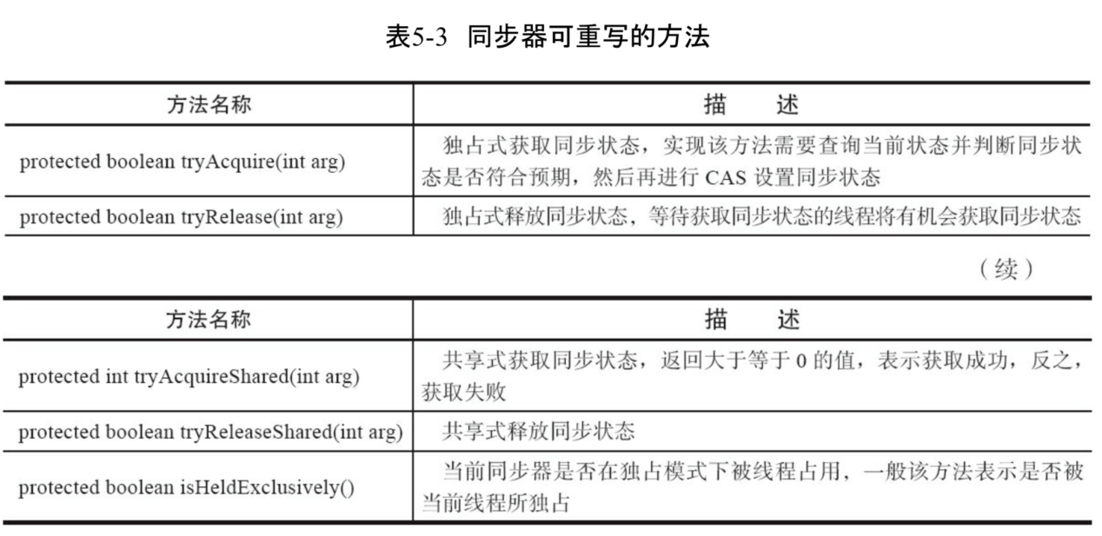

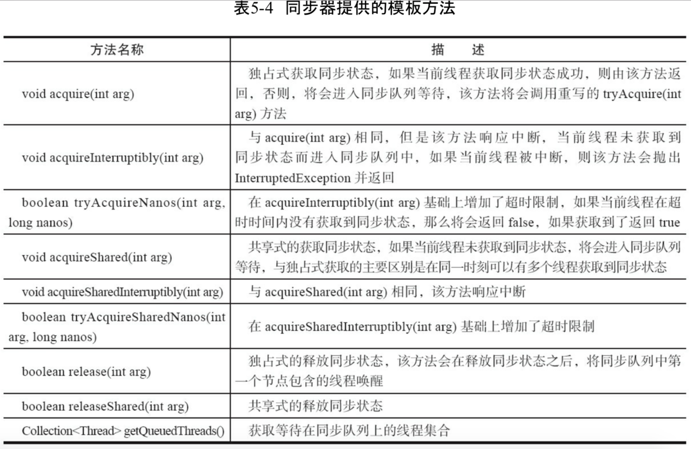

同步器提供的模板方法基本分3类：独占式获取与释放同步状态、共享式获取与释放同步状态和查询同步对列中的等待线程情况。

### 5.2.2 对垒同步器的实现分析

当前线程获取同步状态失败时，同步器会将当前线程以及等待状态等信息构造称为一个节点(Node)并将其加入同步对列，同时会阻塞当前线程。

同步对列中的节点(Node)用来保存获取同步状态失败的线程引用、等待状态以及前驱和后继节点，节点的属性类型与名称。

1.同步对列

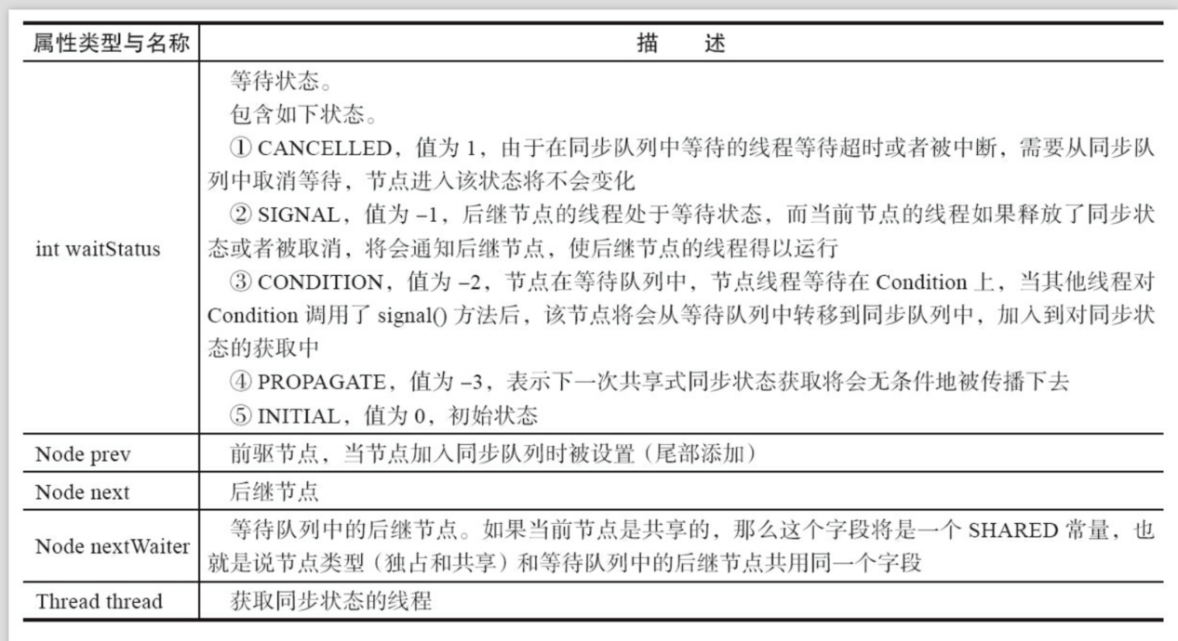

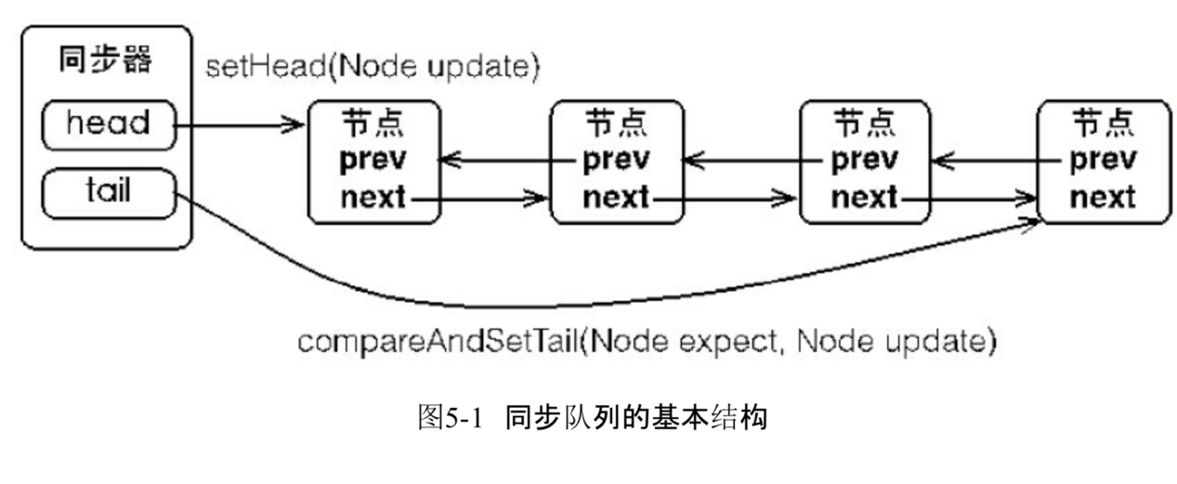

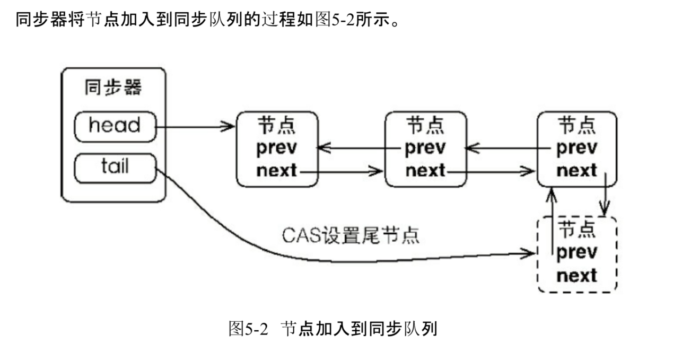

同步对列遵循FIFO先进先出，首节点是获取同步状态成功的节点，首节点的线程在释放同步状态时，将会唤醒后继结点，而后继结点将会在获取同步状态成功时将自己设置为首节点。

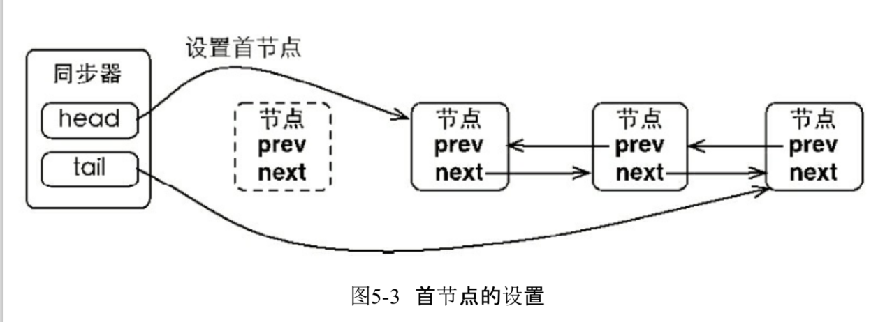

1. 独占式同步状态获取与释放

1.同步器的节点Node类

|  |
| --- |
| static final class Node {  */** Marker to indicate a node is waiting in shared mode */*  *// 共享模式* static final Node *SHARED* = new Node();  */** Marker to indicate a node is waiting in exclusive mode */*  *// 独占模式* static final Node *EXCLUSIVE* = null;   */** waitStatus value to indicate thread has cancelled */*  *// 同步器中线程的状态，已经取消*  *// 表示当前结点已经取消调度。当timeeout或被中断，会触发变更为此状态，进入该状态后的结点将不会再变化* static final int *CANCELLED* = 1;  */** waitStatus value to indicate successor's thread needs unparking */*  *// 唤醒*  *// 表示后继结点在等待当前结点唤醒。后继结点入队时，会将前驱结点结点状态更新为SIGNAL* static final int *SIGNAL* = -1;  */** waitStatus value to indicate thread is waiting on condition */*  *// 有条件的等待*  *// 表示结点等待在Condition上，当其他线程调用了Condition的signal方法后，CONDITION状态将从等待对列庄毅到同步对列中，等待获取同步锁* static final int *CONDITION* = -2;  */**  * waitStatus value to indicate the next acquireShared should  * unconditionally propagate  */*  *// 下一个共享获取是无条件传播*  *// 共享模式下，前驱结点不仅会唤醒其后继结点，同时也可能会唤醒后继的后继结点* static final int *PROPAGATE* = -3;   */**  * Status field, taking on only the values:  * SIGNAL: The successor of this node is (or will soon be)  * blocked (via park), so the current node must  * unpark its successor when it releases or  * cancels. To avoid races, acquire methods must  * first indicate they need a signal,  * then retry the atomic acquire, and then,  * on failure, block.*  *\* 后继节点阻塞。当前结点释放或者取消时，需要唤醒后继。为了避*  *\* 免竞争，获取方法必须需要一个唤醒信号，然后原子性重试获取  * CANCELLED: This node is cancelled due to timeout or interrupt.  * Nodes never leave this state. In particular,  * a thread with cancelled node never again blocks.*  *\* 节点被取消应为超时或者中断。  * CONDITION: This node is currently on a condition queue.  * It will not be used as a sync queue node  * until transferred, at which time the status  * will be set to 0. (Use of this value here has  * nothing to do with the other uses of the  * field, but simplifies mechanics.)*  *\* 当前结点在条件对列里。它不能被用做同步对列节点知道被转化*  *\* 同时，状态被设为为0，  * PROPAGATE: A releaseShared should be propagated to other  * nodes. This is set (for head node only) in  * doReleaseShared to ensure propagation  * continues, even if other operations have  * since intervened.  * 0: None of the above*  *\* 新结点入队时的默认状态是0  *  * The values are arranged numerically to simplify use.  * Non-negative values mean that a node doesn't need to  * signal. So, most code doesn't need to check for particular  * values, just for sign.  *  * The field is initialized to 0 for normal sync nodes, and  * CONDITION for condition nodes. It is modified using CAS  * (or when possible, unconditional volatile writes).  */* volatile int waitStatus;   */**  * Link to predecessor node that current node/thread relies on  * for checking waitStatus. Assigned during enqueuing, and nulled  * out (for sake of GC) only upon dequeuing. Also, upon  * cancellation of a predecessor, we short-circuit while  * finding a non-cancelled one, which will always exist  * because the head node is never cancelled: A node becomes  * head only as a result of successful acquire. A  * cancelled thread never succeeds in acquiring, and a thread only  * cancels itself, not any other node.  */*  *// 上一个节点* volatile Node prev;   */**  * Link to the successor node that the current node/thread  * unparks upon release. Assigned during enqueuing, adjusted  * when bypassing cancelled predecessors, and nulled out (for  * sake of GC) when dequeued. The enq operation does not  * assign next field of a predecessor until after attachment,  * so seeing a null next field does not necessarily mean that  * node is at end of queue. However, if a next field appears  * to be null, we can scan prev's from the tail to  * double-check. The next field of cancelled nodes is set to  * point to the node itself instead of null, to make life  * easier for isOnSyncQueue.  */*  *// 下一个结点* volatile Node next;   */**  * The thread that enqueued this node. Initialized on  * construction and nulled out after use.  */*  *// 被阻塞或被唤醒的结点线程* volatile Thread thread;   */**  * Link to next node waiting on condition, or the special  * value SHARED. Because condition queues are accessed only  * when holding in exclusive mode, we just need a simple  * linked queue to hold nodes while they are waiting on  * conditions. They are then transferred to the queue to  * re-acquire. And because conditions can only be exclusive,  * we save a field by using special value to indicate shared  * mode.  */*  *// 下一个等待结点在条件等待对列或者特殊的共享模式下。*  *// 主要是共享模式下使用* Node nextWaiter;   */**  * Returns true if node is waiting in shared mode.  */* final boolean isShared() {  return nextWaiter == *SHARED*;  }   */**  * Returns previous node, or throws NullPointerException if null.  * Use when predecessor cannot be null. The null check could  * be elided, but is present to help the VM.  *  \** ***@return*** *the predecessor of this node  */* final Node predecessor() throws NullPointerException {  Node p = prev;  if (p == null)  throw new NullPointerException();  else  return p;  }   Node() { // Used to establish initial head or SHARED marker  }   Node(Thread thread, Node mode) { // Used by addWaiter  this.nextWaiter = mode;  this.thread = thread;  }   Node(Thread thread, int waitStatus) { // Used by Condition  this.waitStatus = waitStatus;  this.thread = thread;  } } |

2.同步器的acquire方法，可以获取同步状态，该方法对中断不敏感。

|  |
| --- |
| */**  * Acquires in exclusive mode, ignoring interrupts. Implemented  * by invoking at least once {****@link*** *#tryAcquire},  * returning on success. Otherwise the thread is queued, possibly  * repeatedly blocking and unblocking, invoking {****@link*** *\* #tryAcquire} until success. This method can be used  * to implement method {****@link*** *Lock#lock}.  *  \** ***@param*** *arg the acquire argument. This value is conveyed to  * {****@link*** *#tryAcquire} but is otherwise uninterpreted and  * can represent anything you like.  */* public final void acquire(int arg) {  // tryAcquire获取同步状态  // addWaiter(Node.*EXCLUSIVE*) 以独占模式构造Node加入对尾  // acquireQueued方法是死循环获取获取同步状态，返回是否中断的标志  // 整个方法就是尝试获取同步状态失败，然后死循环方式获取同步状态，若是也失败  // 则调用*selfInterrupt进行中断*  if (!tryAcquire(arg) &&  acquireQueued(addWaiter(Node.*EXCLUSIVE*), arg))  *selfInterrupt*(); }  // 这个方法是模板方法，需要子类自己实现  protected boolean tryAcquire(int arg) {  throw new UnsupportedOperationException(); }  // 构造一个结点，并且放置在对尾  private Node addWaiter(Node mode) {  // 当前线程构造节点放置在对尾  Node node = new Node(Thread.*currentThread*(), mode);  // Try the fast path of enq; backup to full enq on failure  // 尾部结点  Node pred = tail;  if (pred != null) {  // cas修改当前结点为尾部结点  node.prev = pred;  if (compareAndSetTail(pred, node)) {  // 修改成功直接返回  pred.next = node;  return node;  }  }  // 若是前面没有修改成功，那么则死循环进行修改  enq(node);  return node; }  private Node enq(final Node node) {  for (;;) {  Node t = tail;  //初始化对列，头结点和尾结点指向同一个结点  if (t == null) { // Must initialize  // 构造了一个”空“节点为head节点。  if (compareAndSetHead(new Node()))  tail = head;  } else {  // 修改为尾结点  // 这里三个步骤，当前node节点的前驱指向尾节点  // cas将node设置为节点  // 将之前的尾节点的后继节点指向node  // 这三个步骤不是原子操作，且cas有可能失败  // 所以就出现了尾分叉的现象  // 尾分叉会导致很多个尾节点指向同一个前驱  // 但是前驱却为指向为节点，也就出现了pred.next==null的情况  node.prev = t;  if (compareAndSetTail(t, node)) {  t.next = node;  return t;  }  }  } }      // 下面死循环获取同步状态  // 入队获取同步状态失败的结点：进入等待状态休息，直到其他线程彻底释放资源后唤醒自己，自己在拿到资源，然后就可以去干自己想干的事了。  final boolean acquireQueued(final Node node, int arg) {  boolean failed = true;// 标记是否成功拿到资源  try {  boolean interrupted = false;// 标记等待过程中是否被中断过  for (;;) {  // 新入尾部的结点的前驱节点  final Node p = node.predecessor();  // 如果前驱节点是头节点，并且尝试获取同步状态成功  if (p == head && tryAcquire(arg)) {  // 把node设置为头结点  setHead(node);  // 将之前的头结点进行出队  p.next = null; // help GC  failed = false;  // 返回等待过程中是否被中断过  return interrupted;  }  // 如果自己可以休息，就通过park()进入waiting状态，知道被  // unpark().如果不可中断的情况下被中断了，那么会从park()中  // 醒过来,发现拿不到资源继续进入park()等待  // 走到这里的线程，说明，构造的节点的前驱不是头结点,或者它  // 争夺锁资源失败，那么就需要将这个线程进行park,即等待。  // 并且判断等待过程中是否被中断过  if (*shouldParkAfterFailedAcquire*(p, node) &&  parkAndCheckInterrupt())  // 如果等待过程中被中断过，就标记被中断过  interrupted = true;  }  } finally {  if (failed)  cancelAcquire(node);  } }  // 返回true，应该被阻塞  private static boolean shouldParkAfterFailedAcquire(Node pred, Node node) {  // 前驱结点的状态  // 在将当前线程park之前，判断先前驱节点的等待状态是否是SIGNAL  // 是的话，就可以直接进行park了  // 不是的话，需要将前驱等待状态是*SIGNAL*  *// 但是，若是前驱ws > 0,说明被取消了，那就往前迭代找到不是取消的节点*  *// 将这个节点置为其前驱节点，且修改装填为SIGNAL*  int ws = pred.waitStatus;   if (ws == Node.*SIGNAL*)  /*  * This node has already set status asking a release  * to signal it, so it can safely park.  */  // 说明已经唤醒过了，现在可以安全的阻塞。  // pred节点已经发出了一个释放请求，那么  return true;  if (ws > 0) {  /*  * Predecessor was cancelled. Skip over predecessors and  * indicate retry.  */  // 大于0是取消状态，  // 那么将该结点移除对列  do {  // 这个代码是移除的操作  node.prev = pred = pred.prev;  } while (pred.waitStatus > 0);  pred.next = node;  } else {  /*  * waitStatus must be 0 or PROPAGATE. Indicate that we  * need a signal, but don't park yet. Caller will need to  * retry to make sure it cannot acquire before parking.  */  // 这里修改状态为唤醒  // 如果前驱状态为0，或者PROGATE状态，那就把前驱状态设置成SIGNAL，告诉他获取资源后，通知自己一下  *compareAndSetWaitStatus*(pred, ws, Node.*SIGNAL*);  }  return false; }  // 将当前线程进行park，休息等待  private final boolean parkAndCheckInterrupt() {  // 是线程进入等待状态  LockSupport.*park*(this);  // 返回是否被中断，并且清除当前线程的中断标识  return Thread.*interrupted*(); }  // 获得失败，取消获得  private void cancelAcquire(Node node) {  // Ignore if node doesn't exist  if (node == null)  return;   node.thread = null;  // 跳过已经取消的前驱结点  // Skip cancelled predecessors  // 前驱结点  Node pred = node.prev;  while (pred.waitStatus > 0)  // 将取消的前驱节点移除对列  node.prev = pred = pred.prev;   // predNext is the apparent node to unsplice. CASes below will  // fail if not, in which case, we lost race vs another cancel  // or signal, so no further action is necessary.  Node predNext = pred.next;   // Can use unconditional write instead of CAS here.  // After this atomic step, other Nodes can skip past us.  // Before, we are free of interference from other threads.  node.waitStatus = Node.*CANCELLED*;   // If we are the tail, remove ourselves.  // cas设置将tail的前驱设置为tail  if (node == tail && compareAndSetTail(node, pred)) {  // 此时pred是对尾，需要将pred.next设置为null  *compareAndSetNext*(pred, predNext, null);  } else {  // If successor needs signal, try to set pred's next-link  // so it will get one. Otherwise wake it up to propagate.  int ws;  if (pred != head &&  ((ws = pred.waitStatus) == Node.*SIGNAL* ||  (ws <= 0 && *compareAndSetWaitStatus*(pred, ws, Node.*SIGNAL*))) &&  pred.thread != null) {  Node next = node.next;  if (next != null && next.waitStatus <= 0)  *compareAndSetNext*(pred, predNext, next);  } else {  unparkSuccessor(node);  }   node.next = node; // help GC  } } |

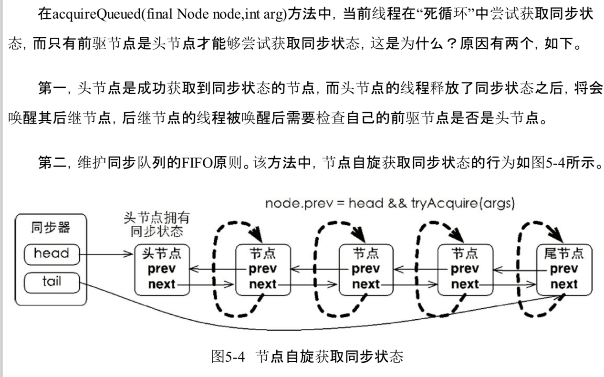

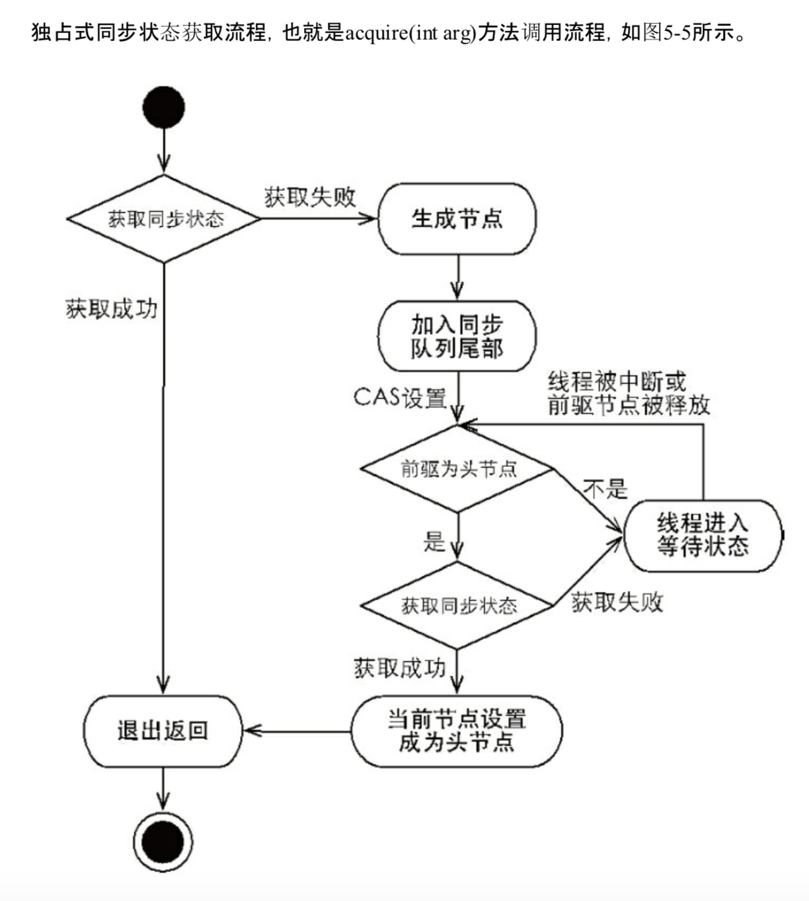

3.release释放同步状态：

|  |
| --- |
| public final boolean release(int arg) {  // 获得同步状态成功  if (tryRelease(arg)) {  // 获取同步状态成功，  Node h = head;  if (h != null && h.waitStatus != 0)  // 唤醒后继结点  unparkSuccessor(h);  return true;  }  return false; }  // 模板方法，需要子类去实现  protected boolean tryRelease(int arg) {  throw new UnsupportedOperationException(); }  private void unparkSuccessor(Node node) {  /*  * If status is negative (i.e., possibly needing signal) try  * to clear in anticipation of signalling. It is OK if this  * fails or if status is changed by waiting thread.  */  int ws = node.waitStatus;  // 设置状态为0  if (ws < 0)  // 设置状态为0，表示已经释放  *compareAndSetWaitStatus*(node, ws, 0);   /*  * Thread to unpark is held in successor, which is normally  * just the next node. But if cancelled or apparently null,  * traverse backwards from tail to find the actual  * non-cancelled successor.  */  // 唤醒后面一个(非空或非取消的结点)  Node s = node.next;  // 后继节点是null或者状态是已经取消  if (s == null || s.waitStatus > 0) {  // 这将s出队列  s = null;  // 从对尾往前遍历，找到结点状态小于0的(即非取消的)  for (Node t = tail; t != null && t != node; t = t.prev)  if (t.waitStatus <= 0)  s = t;  }  if (s != null)  // 将s结点唤醒  LockSupport.*unpark*(s.thread); } |

1. 共享式同步装填获取与释放

|  |
| --- |
| public final void acquireShared(int arg) {  if (tryAcquireShared(arg) < 0)  doAcquireShared(arg); }  protected int tryAcquireShared(int arg) {  throw new UnsupportedOperationException(); }  private void doAcquireShared(int arg) {  // 构造一个共享的结点  final Node node = addWaiter(Node.*SHARED*);  boolean failed = true;  try {  boolean interrupted = false;  // 死循环方式获取同步状态  for (;;) {  // 前驱节点，  final Node p = node.predecessor();  if (p == head) {  // 如果前驱结点是头结点，获取说明可以获取到资源  // state < 0 :表示获取资源失败  // state = 0 :表示当前正好获取到资源  // state > 0 :表示当前线程获取资源锁后，还有多余的资源，  // 需要向后继节点继续传播，获取资源  int r = tryAcquireShared(arg);  //   if (r >= 0) {  //   setHeadAndPropagate(node, r);  p.next = null; // help GC  // 如果等待过程中被中断，将中断补上。  // 等待过程中不响应中断  if (interrupted)  *selfInterrupt*();  failed = false;  return;  }  }  // 判断状态，node结点进入waiting状态  if (*shouldParkAfterFailedAcquire*(p, node) &&  parkAndCheckInterrupt())  interrupted = true;  }  } finally {  if (failed)  cancelAcquire(node);  } }  private void setHeadAndPropagate(Node node, int propagate) {  Node h = head; // Record old head for check below  // 将当前结点设置为head  setHead(node);  /*  * Try to signal next queued node if:  * Propagation was indicated by caller,  * or was recorded (as h.waitStatus either before  * or after setHead) by a previous operation  * (note: this uses sign-check of waitStatus because  * PROPAGATE status may transition to SIGNAL.)  * and  * The next node is waiting in shared mode,  * or we don't know, because it appears null  *  * The conservatism in both of these checks may cause  * unnecessary wake-ups, but only when there are multiple  * racing acquires/releases, so most need signals now or soon  * anyway.  */  // 尝试通知下一个  // 如果资源足够(propagate > 0) 或者旧头结点为空 或者旧头结点的状态为  // SIGNAL或者PROPAGATE 或者当前head结点不为空，或者当前结点状态是  // SIGNAL或者PROPAGATE  if (propagate > 0 || h == null || h.waitStatus < 0 ||  (h = head) == null || h.waitStatus < 0) {  // 当前结点的后继结点。  Node s = node.next;  // 后继及诶单为空或者属于共享节点  if (s == null || s.isShared())  // 继续尝试获取资源  doReleaseShared();  } }  private void doReleaseShared() {  /*  * Ensure that a release propagates, even if there are other  * in-progress acquires/releases. This proceeds in the usual  * way of trying to unparkSuccessor of head if it needs  * signal. But if it does not, status is set to PROPAGATE to  * ensure that upon release, propagation continues.  * Additionally, we must loop in case a new node is added  * while we are doing this. Also, unlike other uses of  * unparkSuccessor, we need to know if CAS to reset status  * fails, if so rechecking.  */  // 这里的头结点已经是上面设定的头结点了，从这里可以看出，如果propagate=0，  // 不会进入到doReleaseShared方法里面，那就有共享模式编程了独占式  for (;;) {// 死循环以方在执行此操作时添加新节点：退出条件h==head  Node h = head;  if (h != null && h != tail) {  int ws = h.waitStatus;  if (ws == Node.*SIGNAL*) {  // 如果当前结点的状态为SIGNAL，则利用CAS将其状态设置为0(也  // 就是初始状态)，这里不直接设为Node.PROPAGATE,是因为  // unparkSuccessor(h)中，如果ws < 0 会设置为0，所以ws先  // 设置为0，再设置为PROPAGATE，这里需要控制并发，因为入口有  // setHeadAndPropagate跟releas两个，避免两次unpark  if (!*compareAndSetWaitStatus*(h, Node.*SIGNAL*, 0))  continue; // loop to recheck cases  unparkSuccessor(h);s  }  // 如果状态为0，则利用CAS将其状态设置为PROPAGATE，以确保在释放  // 资源时能够继续通知后继节点  else if (ws == 0 &&  !*compareAndSetWaitStatus*(h, 0, Node.*PROPAGATE*))  continue; // loop on failed CAS  }  if (h == head) // loop if head changed  break;  } } |

## 5.3 重入锁

在AQS中，state就是代表锁的状态，state=0,表示是可用状态，state>0表示被某个线程持有，重入锁，每重入一次，state++;

|  |
| --- |
| */**  * The synchronization state.  */* private volatile int state; |

在ReentrantLock中，只有如下sync字段，该字段Sync类型是AQS的子类，Sync有两个子类，分别是FairSync(公平)和NonFairSync(非公平)

|  |
| --- |
| */** Synchronizer providing all implementation mechanics */* private final Sync sync; |

上锁的方法和

|  |
| --- |
| public void lock() {  sync.lock(); }  public boolean tryLock() {  return sync.nonfairTryAcquire(1); }  public void unlock() {  sync.release(1); } |

### 5.3.1 公平锁FairSync

lock方法

|  |
| --- |
| final void lock() {  acquire(1); }  这个方法是AQS的方法，但是tryAcquire方法是子类实现的，也就是  public final void acquire(int arg) {  // 尝试获取锁  // 构造独占模式节点，加入同步对列，  //  // 若是在入队，或者抢夺锁资源的时候发生中断，则需要进行中断线程  if (!tryAcquire(arg) &&  acquireQueued(addWaiter(Node.*EXCLUSIVE*), arg))  *selfInterrupt*(); }  protected final boolean tryAcquire(int acquires) {  final Thread current = Thread.*currentThread*();  int c = getState();  if (c == 0) {  // 判断同步对列中是否有前驱节点，没有，说明是头节点，  // 则可以出队获得锁资源  if (!hasQueuedPredecessors() &&  compareAndSetState(0, acquires)) {  setExclusiveOwnerThread(current);  return true;  }  }  else if (current == getExclusiveOwnerThread()) {  // 走到这里，说明是重入了，只需要判断当前线程是否是独占线程  int nextc = c + acquires;  // 重入次数超过int值了，  if (nextc < 0)  throw new Error("Maximum lock count exceeded");  // 走到这里，说明已经获得锁资源了，于是不需要cas操作  setState(nextc);  return true;  }  return false; }  AQS中同步器的方法  public final boolean hasQueuedPredecessors() {  // The correctness of this depends on head being initialized  // before tail and on head.next being accurate if the current  // thread is first in queue.  Node t = tail; // Read fields in reverse initialization order  Node h = head;  Node s;  // 头结点不等于为节点，说明对列不是空，头结点的下一个结点为不为null，且节点的线程==当前线程的话，就可以出队进行争夺锁资源  return h != t &&  ((s = h.next) == null || s.thread != Thread.*currentThread*()); } |

unlock方法

|  |
| --- |
| public void unlock() {  sync.release(1); }  AQS的释放方法，前面分析过了  public final boolean release(int arg) {  if (tryRelease(arg)) {  Node h = head;  if (h != null && h.waitStatus != 0)  // 唤醒后继节点的的线程，去争夺锁资源  // 这里唤醒的线程会在acquireQueued中的  // parkAndCheckInterrupt方法的park出继续执行代码，  unparkSuccessor(h);  return true;  }  return false; }  private final boolean parkAndCheckInterrupt() {  LockSupport.*park*(this);  // 走到这里，说明当前线程被唤醒了，  // 在休息等待的过程中，线程有可能中断了，于是返回中断标志，且清除中断状态  // 接下来，当前线程在acquireQueued方法的死循环中进行尝试获取锁  return Thread.*interrupted*(); }  Sync中的尝试释放方法  protected final boolean tryRelease(int releases) {  // 这里是减去重入的次数  int c = getState() - releases;  // 释放的时候，判断是否是当前线程是独占线程  if (Thread.*currentThread*() != getExclusiveOwnerThread())  throw new IllegalMonitorStateException();  boolean free = false;  if (c == 0) {  // state等于0了才算释放，  free = true;  setExclusiveOwnerThread(null);  }  setState(c);  return free; } |

### 5.3.2 非公平锁UnonFairSync

|  |
| --- |
| final void lock() {  // 将state由0修改为1，表示抢占到锁  if (compareAndSetState(0, 1))  // 当前线程设置为当前线程  setExclusiveOwnerThread(Thread.*currentThread*());  else  // 走到这里，说明是重入了，因为state已经不是0了  // 若是同个线程进入，这进行state++  // AQS的方法  acquire(1); }  protected final boolean tryAcquire(int acquires) {  return nonfairTryAcquire(acquires); }  Sync中方法  final boolean nonfairTryAcquire(int acquires) {  final Thread current = Thread.*currentThread*();  int c = getState();  if (c == 0) {  // 这个比公平锁少了一个判断同步对列是否有前驱节点的方法  if (compareAndSetState(0, acquires)) {  setExclusiveOwnerThread(current);  return true;  }  }  else if (current == getExclusiveOwnerThread()) {  int nextc = c + acquires;  if (nextc < 0) // overflow  throw new Error("Maximum lock count exceeded");  setState(nextc);  return true;  }  return false; } |

公平锁和非公平锁的释放方式都是一样的

只是，在获取锁的时候，公平锁要确保入队最久的那个线程出来争夺锁资源

## 5.4 读写锁

AQS具备特性：

1. 阻塞等待对列
2. 共享/独占
3. 公平/非公平
4. 可重入
5. 允许中断

## 5.6 Condition 接口

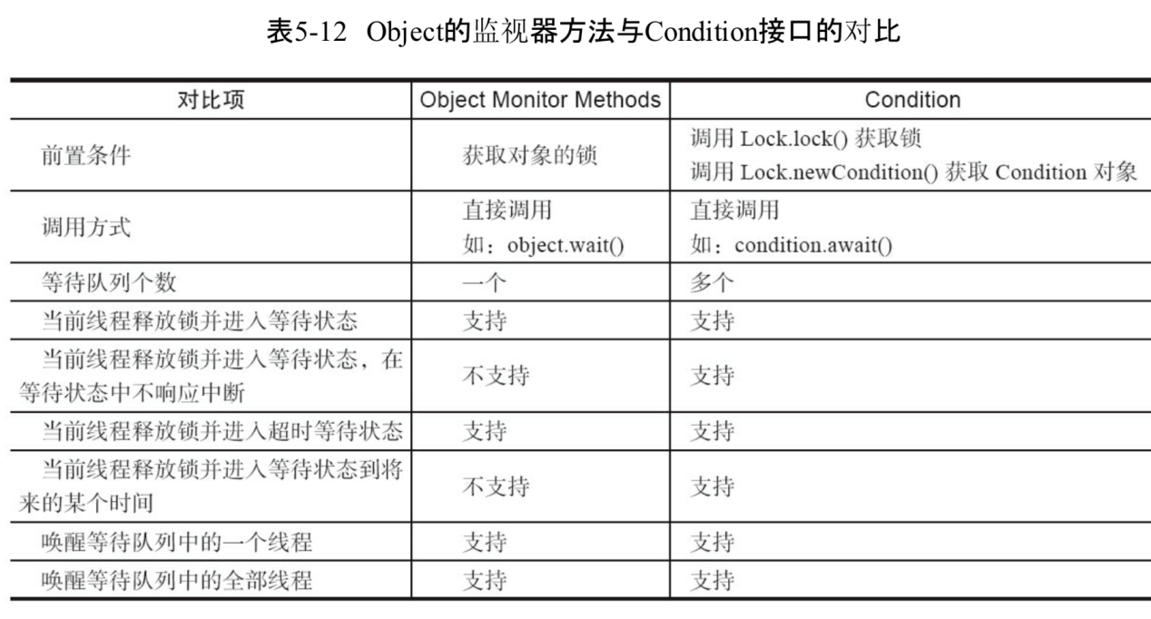

### 5.6.2 Condition的实现分析

Condition的实现，主要包括：等待对列、等待和通知，

1. **等待对列**

**等待对列是一个FIFO的对列，在对列中的每个节点都包含了一个线程引用，该线程就是Condition对象上等待的线程，如果一个线程调用了Condition.await()方法，那么该线程将会释放锁，构造成节点加入等待对列并进入等待状态。事实上，节点的定义复用了同步器中节点的定义，也就是说，同步对列和等待对列中节点类型都是同步器的静态内部类Node。**

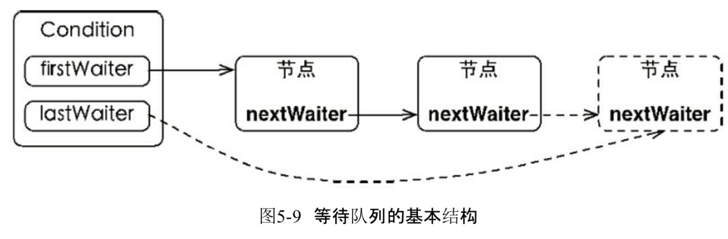

节点应用更新的过程并没有使用CAS保证，原因在于调用await()方法的线程必定是获取了锁的线程，也就是说该过程是由锁来保证线程安全的

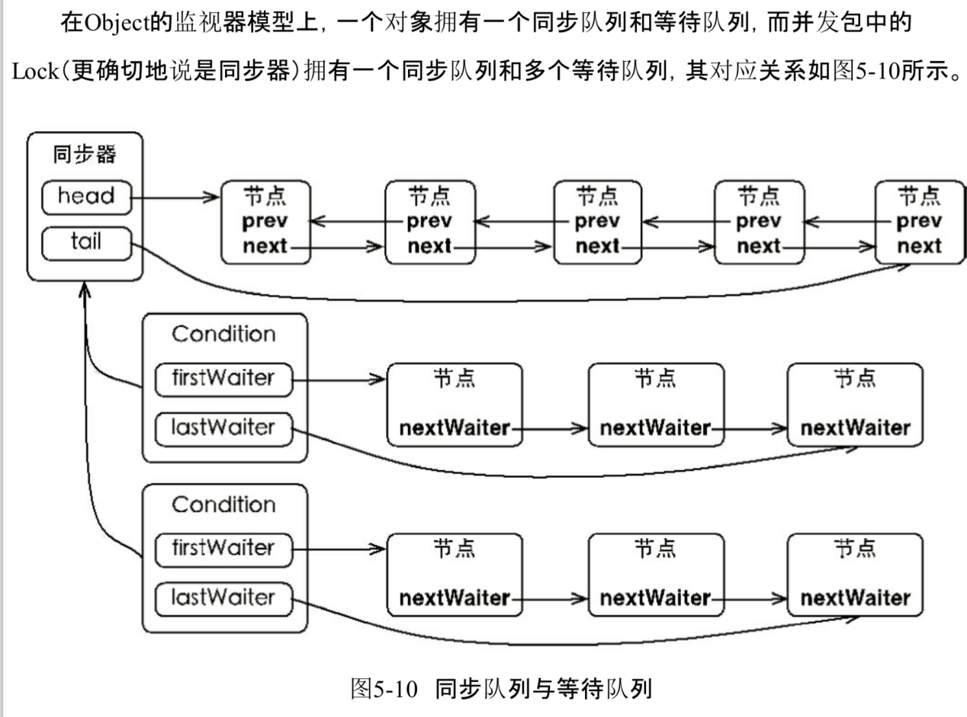

1. 等待

调用await()方法(或者以await开头的方法时)，会使当前线程进入等待对列并释放锁，同时线程状态变为等待状态。当从await()方法返回时，当前线程一定获取了Condition相关的锁。

1. 通知

调用Condition的signal()方法，将会唤醒在等待对列中等待时间最长的节点(首节点)，在唤醒节点之前，会将节点移到同步对列中。

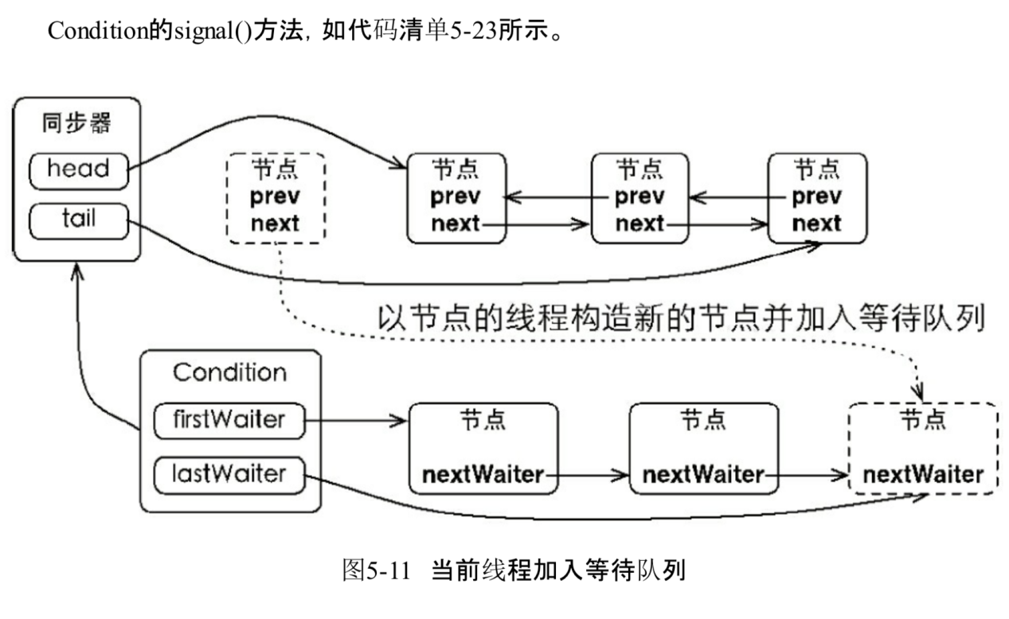

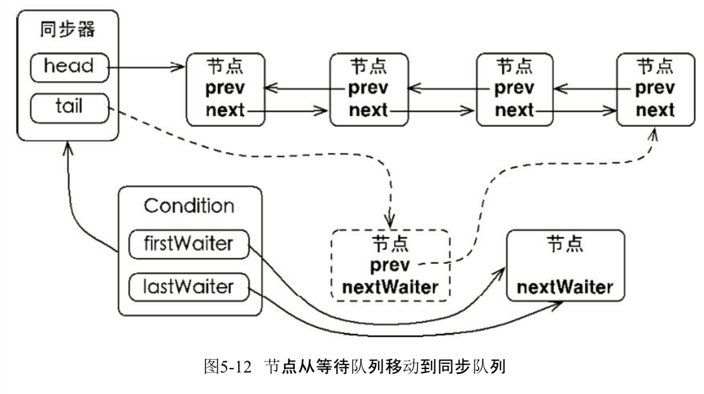

1. 源码分析

入队等待

|  |
| --- |
| public final void await() throws InterruptedException {  // 如果线程已经中断，则抛出异常  if (Thread.*interrupted*())  throw new InterruptedException();  // 构造节点  Node node = addConditionWaiter();  // 释放锁  int savedState = fullyRelease(node);  int interruptMode = 0;  // 判断是否在同步对列中  while (!isOnSyncQueue(node)) {  // 不在同步对列中，这里阻塞  LockSupport.*park*(this);  // 执行到这里，说明要么是signal方法被调用，要么是线程被中断  // 检查线程被唤醒的原因，如果是中断被唤醒，则跳出while循环  if ((interruptMode = checkInterruptWhileWaiting(node)) != 0)  break;  }  if (acquireQueued(node, savedState) && interruptMode != *THROW_IE*)  interruptMode = *REINTERRUPT*;  if (node.nextWaiter != null) // clean up if cancelled  unlinkCancelledWaiters();  if (interruptMode != 0)  reportInterruptAfterWait(interruptMode); }  private Node addConditionWaiter() {  Node t = lastWaiter;  // If lastWaiter is cancelled, clean out.  if (t != null && t.waitStatus != Node.*CONDITION*) {  // 清除掉取消的线程node  unlinkCancelledWaiters();  t = lastWaiter;  }  // 构造一个waitStatus=Node.*CONDITION的节点*  Node node = new Node(Thread.*currentThread*(), Node.*CONDITION*);  // 将该节点加入单链表中  if (t == null)  firstWaiter = node;  else  t.nextWaiter = node;  lastWaiter = node;  return node; }  private void unlinkCancelledWaiters() {  Node t = firstWaiter;  // 类似游标的临时变量节点，  Node trail = null;  while (t != null) {  Node next = t.nextWaiter;  if (t.waitStatus != Node.*CONDITION*) {  // 断开和后一个连接  t.nextWaiter = null;  // 刚开始游标是null,  if (trail == null)  // 将下一个个节点置为第一个节点(应该是第三个或者第三个以后的节点)  firstWaiter = next;  else  // 说明，上一次的迭代的节点是等待状态的node  trail.nextWaiter = next;  if (next == null)  // 说明到达为节点，直接将尾节点指向trail  lastWaiter = trail;  }  else  // 如果状态是等待状态，则直接将trail指向迭代的目标节点  trail = t;  t = next;  } }  final int fullyRelease(Node node) {  // 释放锁失败标志  boolean failed = true;  try {  // 当前的状态  int savedState = getState();  if (release(savedState)) {  failed = false;  return savedState;  } else {  throw new IllegalMonitorStateException();  }  } finally {  if (failed)  node.waitStatus = Node.*CANCELLED*;  } }  public final boolean release(int arg) {  // 尝试进行释放  if (tryRelease(arg)) {  Node h = head;  if (h != null && h.waitStatus != 0)  // 唤醒等待对列中的后继节点  unparkSuccessor(h);  return true;  }  return false; }  final boolean isOnSyncQueue(Node node) {  // 这里明显是在条件等待对列里  if (node.waitStatus == Node.*CONDITION* || node.prev == null)  return false;  // 若是节点的next不为空，则应该在同步对列中  if (node.next != null) // If has successor, it must be on queue  return true;  /*  * node.prev can be non-null, but not yet on queue because  * the CAS to place it on queue can fail. So we have to  * traverse from tail to make sure it actually made it. It  * will always be near the tail in calls to this method, and  * unless the CAS failed (which is unlikely), it will be  * there, so we hardly ever traverse much.  */  return findNodeFromTail(node); }  private boolean findNodeFromTail(Node node) {  Node t = tail;  for (;;) {  if (t == node)  return true;  if (t == null)  return false;  t = t.prev;  } } |

# Java中的线程池

## 9.1 实现原理

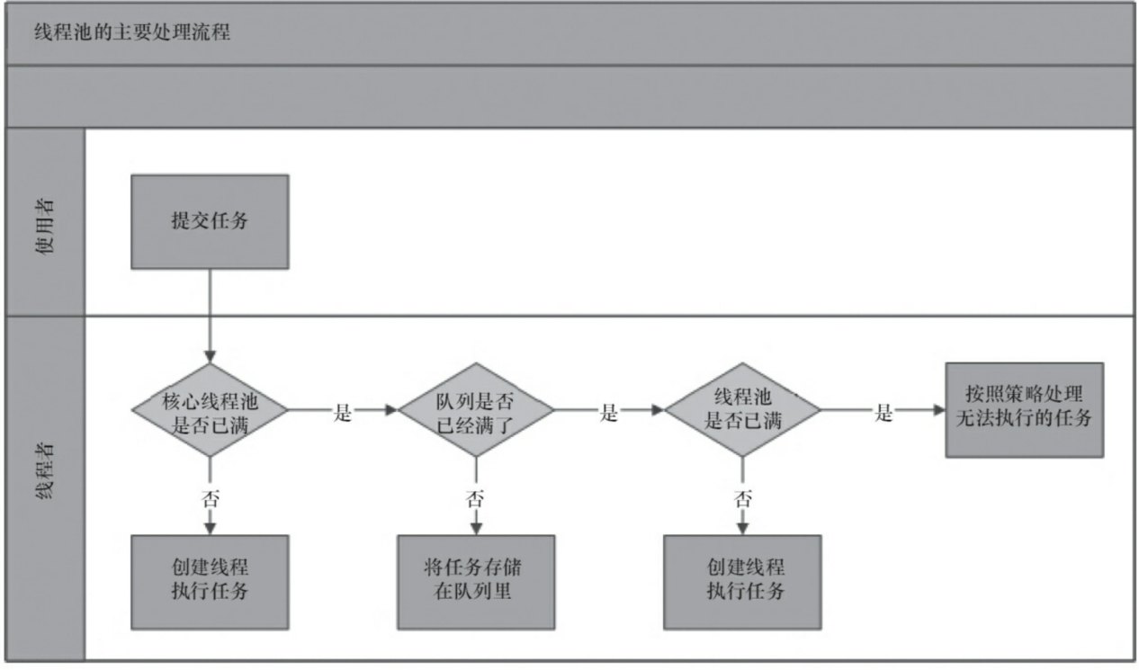

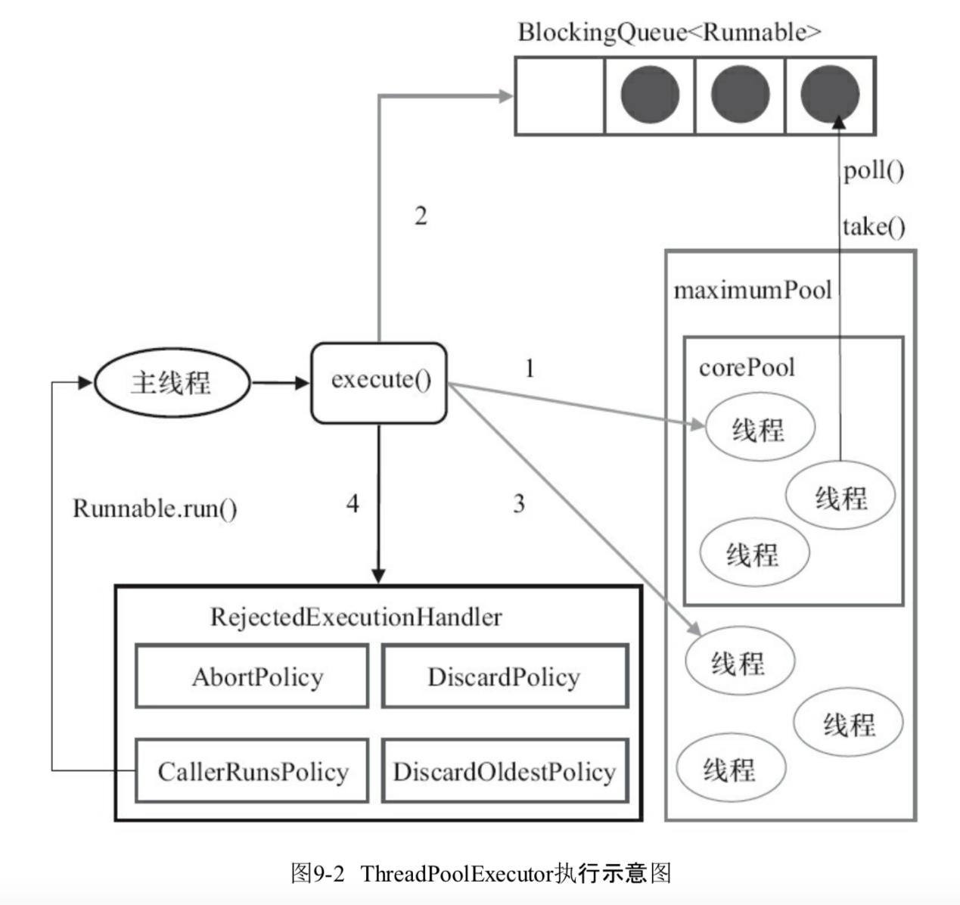

ThreadPoolExecutor执行execute方法：

1. 如果当前运行的线程少于corePoolSize，则创建新线程来执行任务（需要获取全局锁）
2. 如果运行的线程等于或多于corePoolSize，则将任务加入BlockingQueue；
3. 如果无法将任务加入BlockingQueue(对列已满)，则创建新的线程来处理任务(需要获取全局锁)
4. 如果创建新线程将使当前运行的线程超出maximumPoolSize，任务将被拒绝，并调用RejectedExecutionHandler.rejectedExecution()方法

ThreadPoolExecutor的几个字段和状态

|  |
| --- |
| // ctl的二级制的高位3位是状态值，低位29位是池中运行的数量  private final AtomicInteger ctl = new AtomicInteger(*ctlOf*(*RUNNING*, 0));  // *COUNT_BITS = 32 - 3 ，即位数* private static final int *COUNT_BITS* = Integer.*SIZE* - 3;  // 最大容量是2^29-1 private static final int *CAPACITY* = (1 << *COUNT_BITS*) - 1;  // runState is stored in the high-order bits  // RUNNING 运行状态是个负数 private static final int *RUNNING* = -1 << *COUNT_BITS*;  // 始终是0值,不接受新任务，但是处理对列中的任务 private static final int *SHUTDOWN* = 0 << *COUNT_BITS*;  // 不接受新任务，不处理对列中的任务，且对进行重的任务进行中断 private static final int *STOP* = 1 << *COUNT_BITS*;  // 所有任务已经停止，工作线程数量为0，这是个过度状态，在这个状态时，将要执行钩子方法*terminated()* private static final int *TIDYING* = 2 << *COUNT_BITS*;  // 执行完*terminated()方法后的状态* private static final int *TERMINATED* = 3 << *COUNT_BITS*;  // Packing and unpacking ctl  // 从ctl中解包出状态 private static int runStateOf(int c) { return c & ~*CAPACITY*; }  // 从ctl中解包出工作线程数量 private static int workerCountOf(int c) { return c & *CAPACITY*; }  // 将运行状态和工作线程数量包装在ctl这个原子类中 private static int ctlOf(int rs, int wc) { return rs | wc; } |

ThreadPoolExecutor.execute

|  |
| --- |
| public void execute(Runnable command) {  if (command == null)  throw new NullPointerException();  /*  * Proceed in 3 steps:  *  * 1. If fewer than corePoolSize threads are running, try to  * start a new thread with the given command as its first  * task. The call to addWorker atomically checks runState and  * workerCount, and so prevents false alarms that would add  * threads when it shouldn't, by returning false.  * 1.正在执行的线程数少于corePoolSize，尝试创建新的线程(Worker)执行command(作为Worker的firstTask)，  * 调用addWorker方法检测runState(运行状态)和workerCount(工作线程数量)，  *  *  * 2. If a task can be successfully queued, then we still need  * to double-check whether we should have added a thread  * (because existing ones died since last checking) or that  * the pool shut down since entry into this method. So we  * recheck state and if necessary roll back the enqueuing if  * stopped, or start a new thread if there are none.  * 2. 如果任务成功加入对列中，还需要双重检测是否已经加入线程或者线程池是否关闭，  * 我们重检测状态，而且若是有必要需要将刚加入对列的任务回滚出列  * 3. If we cannot queue task, then we try to add a new  * thread. If it fails, we know we are shut down or saturated  * and so reject the task.  * 若是不能如对列，尝试创建新的线程，若是创建线程也失败了，就表名线程池应该是关闭了，  * 需要执行拒绝  */  int c = ctl.get();  if (workerCountOf(c) < corePoolSize) {  if (addWorker(command, true))  return;  c = ctl.get();  }  if (isRunning(c) && workQueue.offer(command)) {  int recheck = ctl.get();  if (! isRunning(recheck) && remove(command))  reject(command);  else if (workerCountOf(recheck) == 0)  addWorker(null, false);  }  else if (!addWorker(command, false))  reject(command); } |

ThreadPoolExecutor.addWorker

|  |
| --- |
| private boolean addWorker(Runnable firstTask, boolean core) {  retry:  for (;;) {  // ctl是表示正在运行线程数量的原子类，包含了状态和数量  // 二进制的高三位表示状态，剩下的29位表示运行的数量  int c = ctl.get();  // 运行状态  int rs = *runStateOf*(c);   // Check if queue empty only if necessary.  // 对列是空的，状态不是RUNNING  if (rs >= *SHUTDOWN* &&  ! (rs == *SHUTDOWN* &&  firstTask == null &&  ! workQueue.isEmpty()))  return false;  // 主要是自旋通过CAS修改ctl的值  for (;;) {  int wc = *workerCountOf*(c);  if (wc >= *CAPACITY* ||  wc >= (core ? corePoolSize : maximumPoolSize))  return false;  // 这里是cas修改操作，是加了一次，即运行数量类加了一次  if (compareAndIncrementWorkerCount(c))  break retry;  // 再次检测状态是否正确  c = ctl.get(); // Re-read ctl  if (*runStateOf*(c) != rs)  continue retry;  // else CAS failed due to workerCount change; retry inner loop  }  }   boolean workerStarted = false;  boolean workerAdded = false;  Worker w = null;  try {  // 创建工作线程  w = new Worker(firstTask);  final Thread t = w.thread;  if (t != null) {  final ReentrantLock mainLock = this.mainLock;  mainLock.lock();  try {  // Recheck while holding lock.  // Back out on ThreadFactory failure or if  // shut down before lock acquired.  int rs = *runStateOf*(ctl.get());  // 将创建的工作线程加入线程池中workers(是个HashSet)  if (rs < *SHUTDOWN* ||  (rs == *SHUTDOWN* && firstTask == null)) {  if (t.isAlive()) // precheck that t is startable  throw new IllegalThreadStateException();  workers.add(w);  int s = workers.size();  // 更新线程池大小  if (s > largestPoolSize)  largestPoolSize = s;  workerAdded = true;  }  } finally {  mainLock.unlock();  }  if (workerAdded) {  // 若是新工作线程加入成功，需要启动工作线程  t.start();  workerStarted = true;  }  }  } finally {  // 启动失败，这进行失败的处理  if (! workerStarted)  addWorkerFailed(w);  }  return workerStarted; } |

ThreadPoolExecutor.addWorkerFailed

|  |
| --- |
| private void addWorkerFailed(Worker w) {  final ReentrantLock mainLock = this.mainLock;  mainLock.lock();  try {  if (w != null)  // 从线程池中移除  workers.remove(w);  // 并且将工作线程数量减去1  decrementWorkerCount();  // 尝试进行终止  tryTerminate();  } finally {  mainLock.unlock();  } } |

|  |
| --- |
| final void tryTerminate() {  for (;;) {  int c = ctl.get();  // 正在运行，状态是*TIDYING或者状态是SHUTDOWN 但对列不是空的都不进行终止*  if (*isRunning*(c) ||  *runStateAtLeast*(c, *TIDYING*) ||  (*runStateOf*(c) == *SHUTDOWN* && ! workQueue.isEmpty()))  return;  if (*workerCountOf*(c) != 0) { // Eligible to terminate  // 随机终止一个线程  interruptIdleWorkers(*ONLY_ONE*);  return;  }   final ReentrantLock mainLock = this.mainLock;  mainLock.lock();  try {  // 尝试将ctl修改为运行线程数量是0，运行状态是*TIDYING的值*  if (ctl.compareAndSet(c, *ctlOf*(*TIDYING*, 0))) {  try {  terminated();  } finally {  // 最后将ctl状态修改为*TERMINATED*  ctl.set(*ctlOf*(*TERMINATED*, 0));  // 唤醒wait的线程  termination.signalAll();  }  return;  }  } finally {  mainLock.unlock();  }  // else retry on failed CAS  } } |

Worker线程

worker是继承AQS同步器，实现Runnable的线程，

|  |
| --- |
| private final class Worker  extends AbstractQueuedSynchronizer  implements Runnable {  */**  * This class will never be serialized, but we provide a  * serialVersionUID to suppress a javac warning.  */* private static final long *serialVersionUID* = 6138294804551838833L;   */** Thread this worker is running in. Null if factory fails. */  // 工作线程*  final Thread thread;  */** Initial task to run. Possibly null. */*  *// 任务线程，新建Worker时，传入的任务就是赋给这个值，当新建的任务执行完后*  *// worker回去对列中取去任务执行* Runnable firstTask;  */** Per-thread task counter */*  *// 每个worker完成的任务数量* volatile long completedTasks;   */**  * Creates with given first task and thread from ThreadFactory.  \** ***@param*** *firstTask the first task (null if none)  */* Worker(Runnable firstTask) {  setState(-1); // inhibit interrupts until runWorker  this.firstTask = firstTask;  // 通过工厂新生成一个worker线程,Worker是Runnable，这里是将Worker  // 转成能启动的Thread  this.thread = getThreadFactory().newThread(this);  }   */** Delegates main run loop to outer runWorker */* public void run() {  // 这个是worker线程处理任务的方法  runWorker(this);  }   // Lock methods  //  // The value 0 represents the unlocked state.  // The value 1 represents the locked state.   protected boolean isHeldExclusively() {  return getState() != 0;  }   protected boolean tryAcquire(int unused) {  if (compareAndSetState(0, 1)) {  setExclusiveOwnerThread(Thread.*currentThread*());  return true;  }  return false;  }   protected boolean tryRelease(int unused) {  setExclusiveOwnerThread(null);  setState(0);  return true;  }   public void lock() { acquire(1); }  public boolean tryLock() { return tryAcquire(1); }  public void unlock() { release(1); }  public boolean isLocked() { return isHeldExclusively(); }   void interruptIfStarted() {  Thread t;  if (getState() >= 0 && (t = thread) != null && !t.isInterrupted()) {  try {  t.interrupt();  } catch (SecurityException ignore) {  }  }  } } |

ThreadPoolExecutor.runWorker

|  |
| --- |
| final void runWorker(Worker w) {  // 当前运行的线程  Thread wt = Thread.*currentThread*();  // 任务线程  Runnable task = w.firstTask;  // 将worker的任务置空  w.firstTask = null;  w.unlock(); // allow interrupts  boolean completedAbruptly = true;  try {  while (task != null || (task = getTask()) != null) {  w.lock();  // If pool is stopping, ensure thread is interrupted;  // if not, ensure thread is not interrupted. This  // requires a recheck in second case to deal with  // shutdownNow race while clearing interrupt  // 如果线程次正在停止，确保线程已经中断  // 如果不是，确保线程没有被中断，  if ((*runStateAtLeast*(ctl.get(), *STOP*) ||  (Thread.*interrupted*() &&  *runStateAtLeast*(ctl.get(), *STOP*))) &&  !wt.isInterrupted())  wt.interrupt();  try {  // 钩子方法，空方法  beforeExecute(wt, task);  Throwable thrown = null;  try {  task.run();  } catch (RuntimeException x) {  thrown = x; throw x;  } catch (Error x) {  thrown = x; throw x;  } catch (Throwable x) {  thrown = x; throw new Error(x);  } finally {  // 钩子方法，空方法  afterExecute(task, thrown);  }  } finally {  task = null;  w.completedTasks++;  w.unlock();  }  }  completedAbruptly = false;  } finally {  // worker线程处理完之后的处理  processWorkerExit(w, completedAbruptly);  } } |

ThreadPoolExecutor.processWorkerExit

|  |
| --- |
| private void processWorkerExit(Worker w, boolean completedAbruptly) {  if (completedAbruptly) // If abrupt, then workerCount wasn't adjusted  decrementWorkerCount();   final ReentrantLock mainLock = this.mainLock;  mainLock.lock();  try {  completedTaskCount += w.completedTasks;  workers.remove(w);  } finally {  mainLock.unlock();  }   tryTerminate();   int c = ctl.get();  if (*runStateLessThan*(c, *STOP*)) {  if (!completedAbruptly) {  int min = allowCoreThreadTimeOut ? 0 : corePoolSize;  if (min == 0 && ! workQueue.isEmpty())  min = 1;  if (*workerCountOf*(c) >= min)  return; // replacement not needed  }  addWorker(null, false);  } } |

DefaultThreadFactory:默认的线程工厂实现

其实就是维护了个线程组

|  |
| --- |
| static class DefaultThreadFactory implements ThreadFactory {  private static final AtomicInteger *poolNumber* = new AtomicInteger(1);  private final ThreadGroup group;  private final AtomicInteger threadNumber = new AtomicInteger(1);  private final String namePrefix;   DefaultThreadFactory() {  SecurityManager s = System.*getSecurityManager*();  group = (s != null) ? s.getThreadGroup() :  Thread.*currentThread*().getThreadGroup();  namePrefix = "pool-" +  *poolNumber*.getAndIncrement() +  "-thread-";  }   public Thread newThread(Runnable r) {  Thread t = new Thread(group, r,  namePrefix + threadNumber.getAndIncrement(),  0);  if (t.isDaemon())  t.setDaemon(false);  if (t.getPriority() != Thread.*NORM_PRIORITY*)  t.setPriority(Thread.*NORM_PRIORITY*);  return t;  } } |

## 9.2 线程池使用



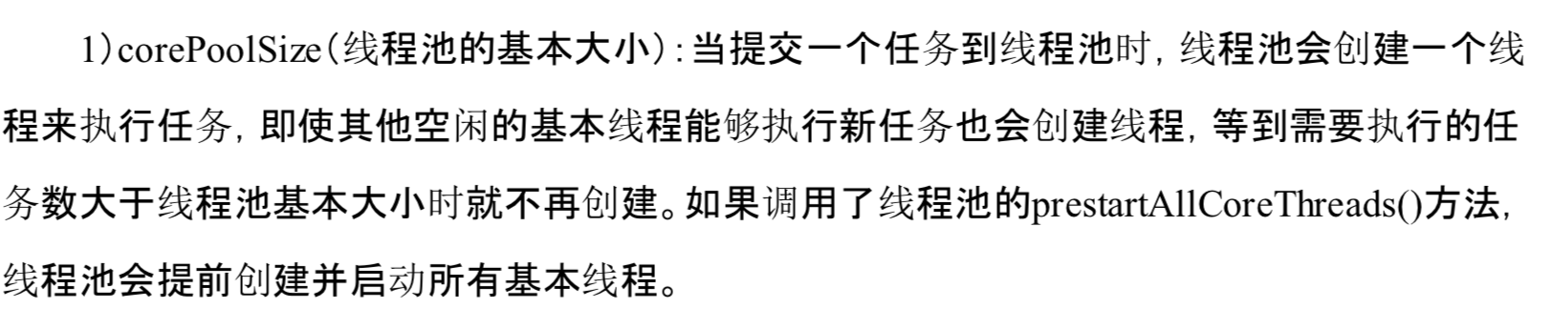

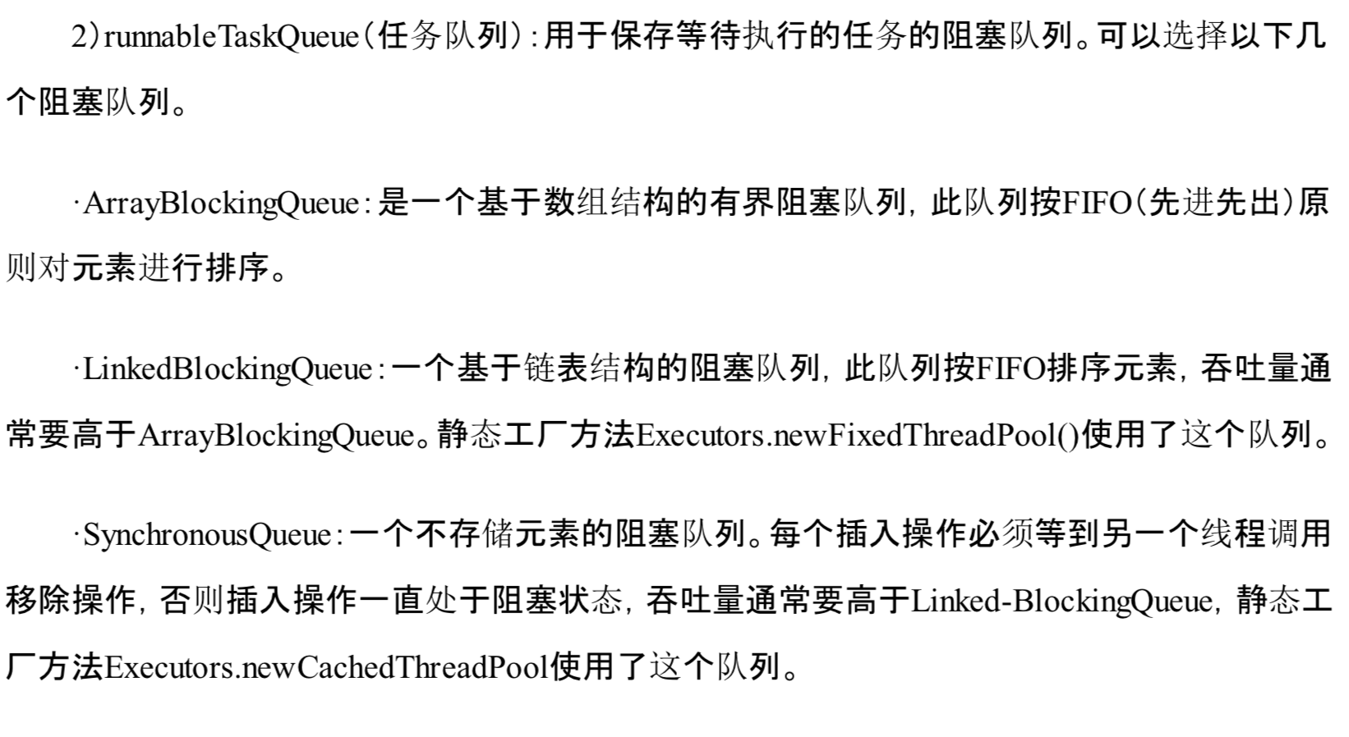

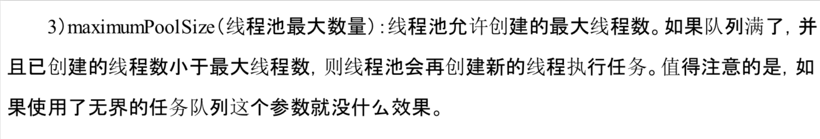

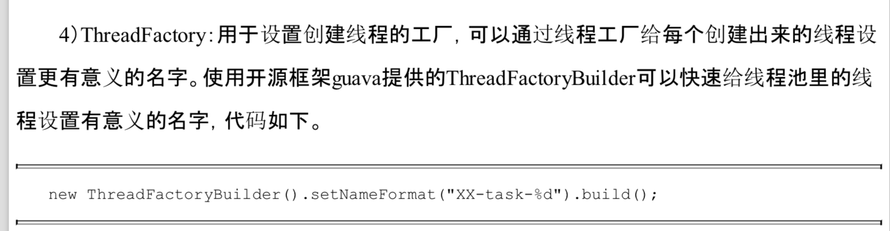

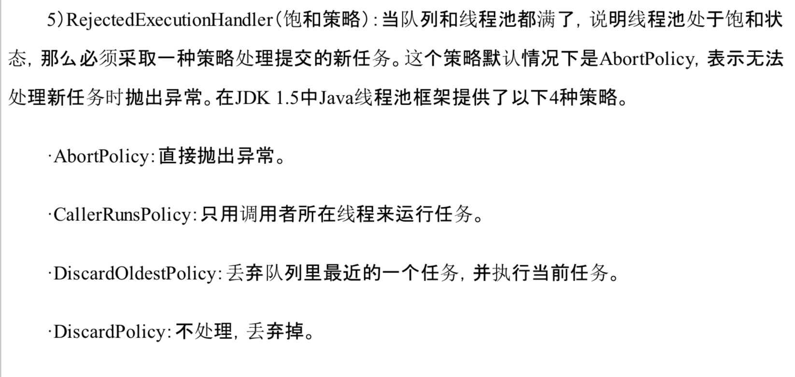

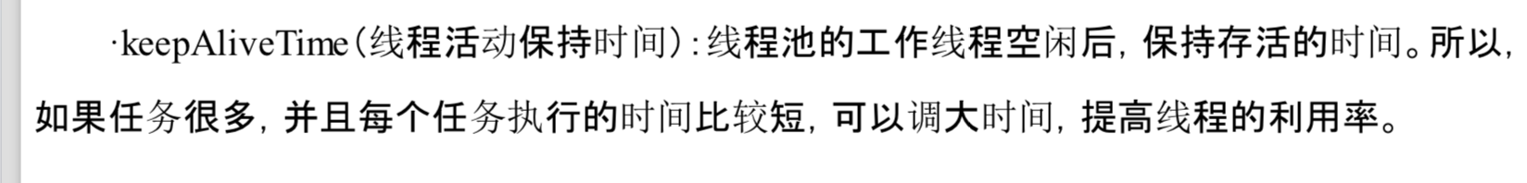

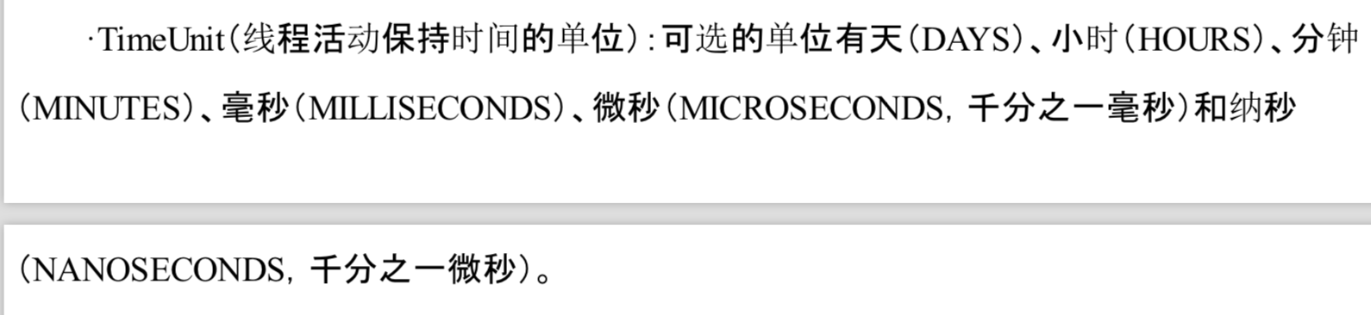

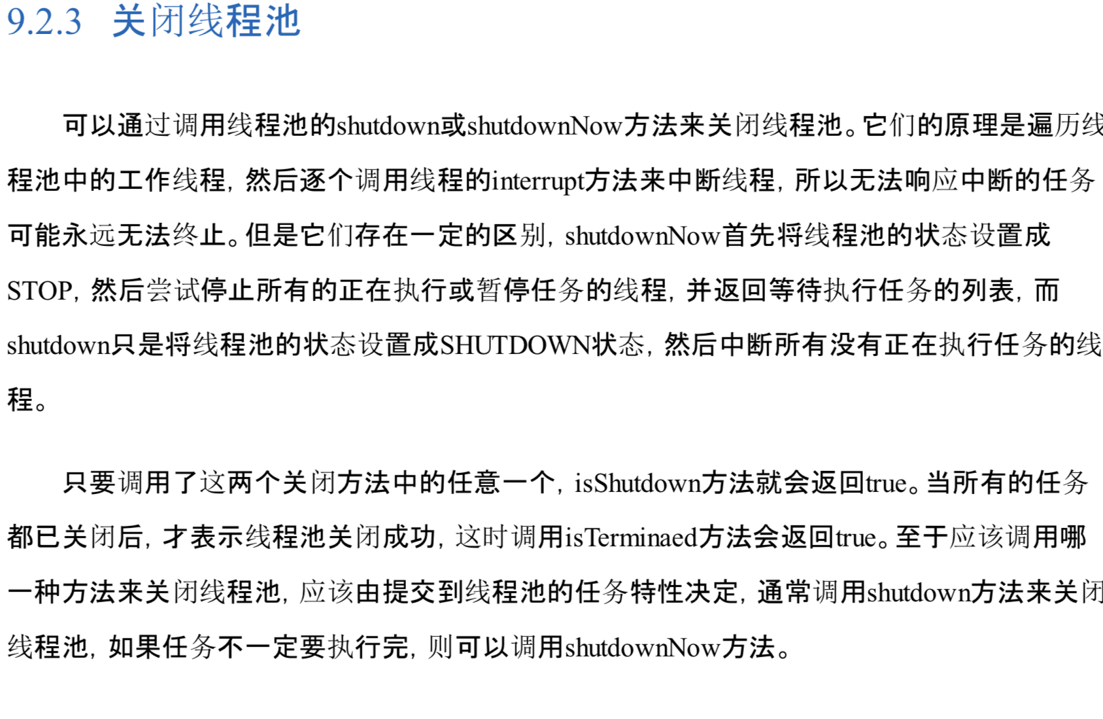

# Executor框架

## 10.1 Executor简介

Executor框架主要由3大部分组成：

1. 任务。包括被执行的任务，需要实现的接口：Runnable接口或Callable接口
2. 任务的执行：包括任务执行机制的核心接口Executor，以及继承自Executor的ExecutorService接口。Executor框架有两个关键类实现了ExecutorService接口(ThreadPoolExecutor和ScheduledThreadPoolExecutor)
3. 异步计算结果：包括接口Future和实现Future接口的FutureTask类。

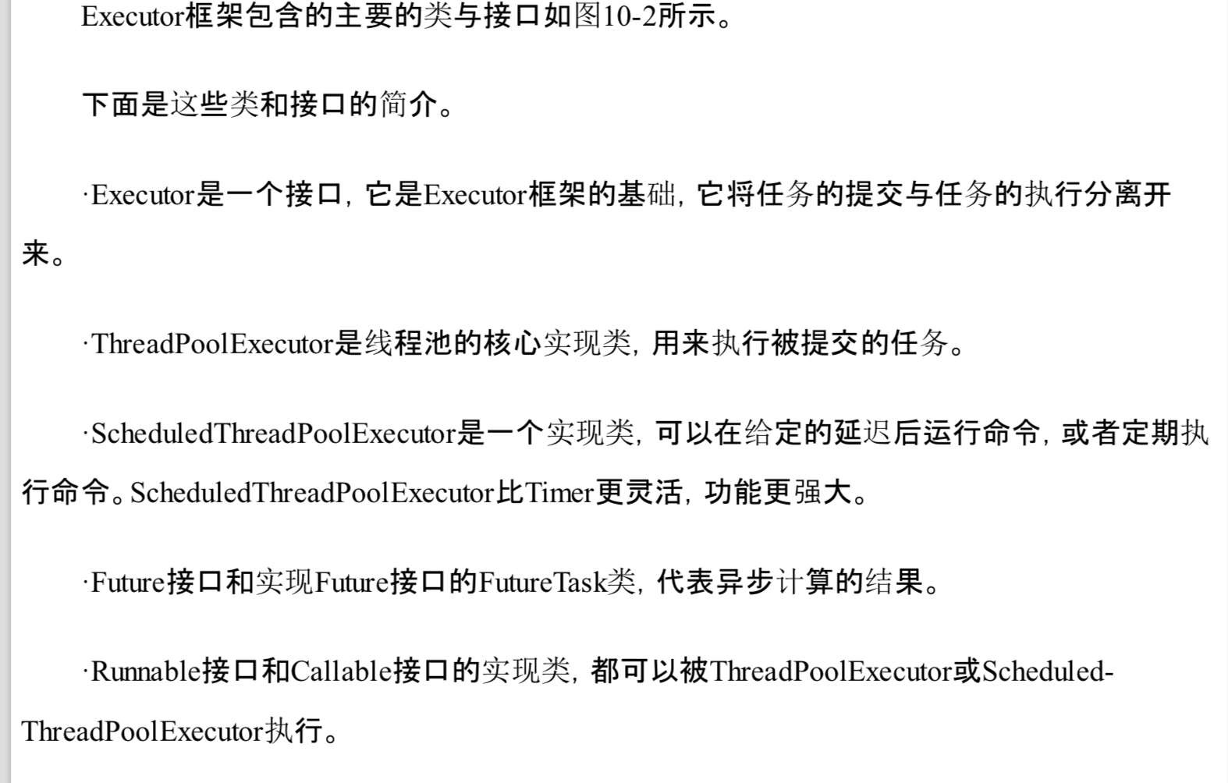

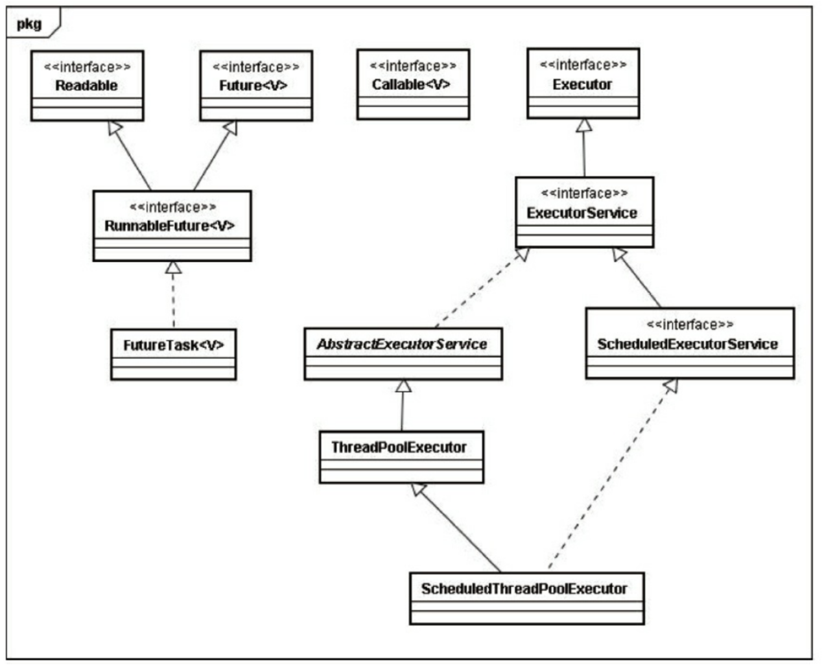

## 10.2 ThreadPoolExecutor详解

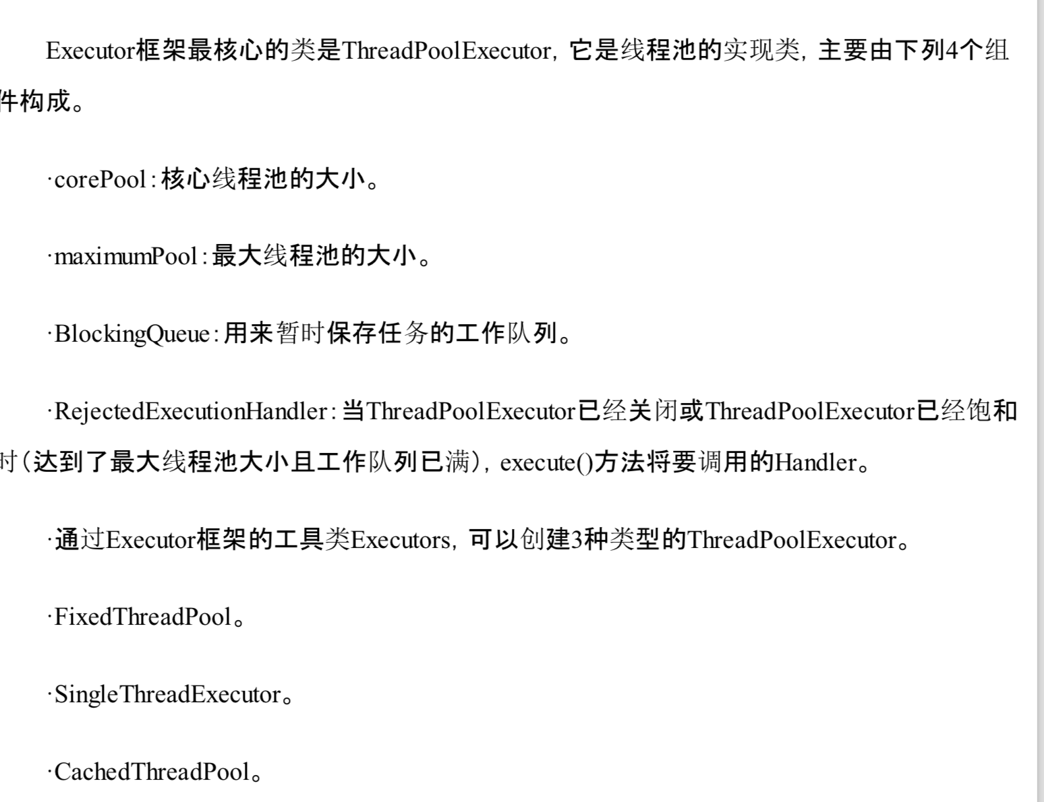

### 10.2.1 FixedThreadPool详解

FixedThreadPool可重用固定线程数的线程池。

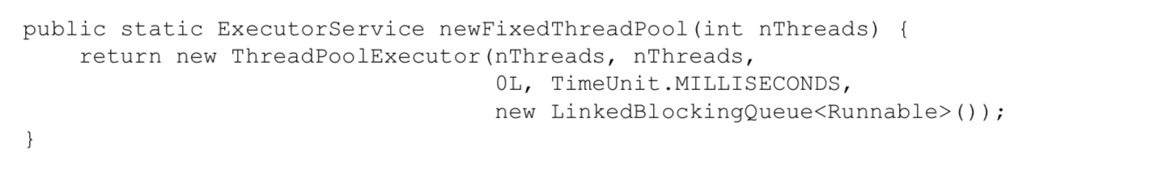

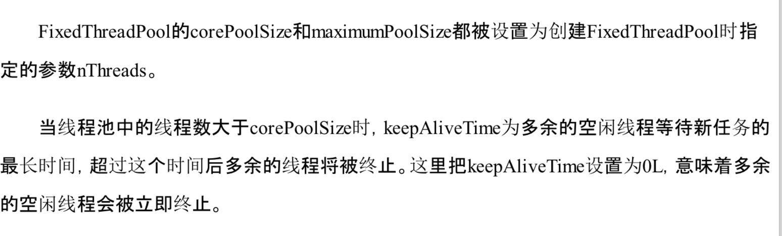

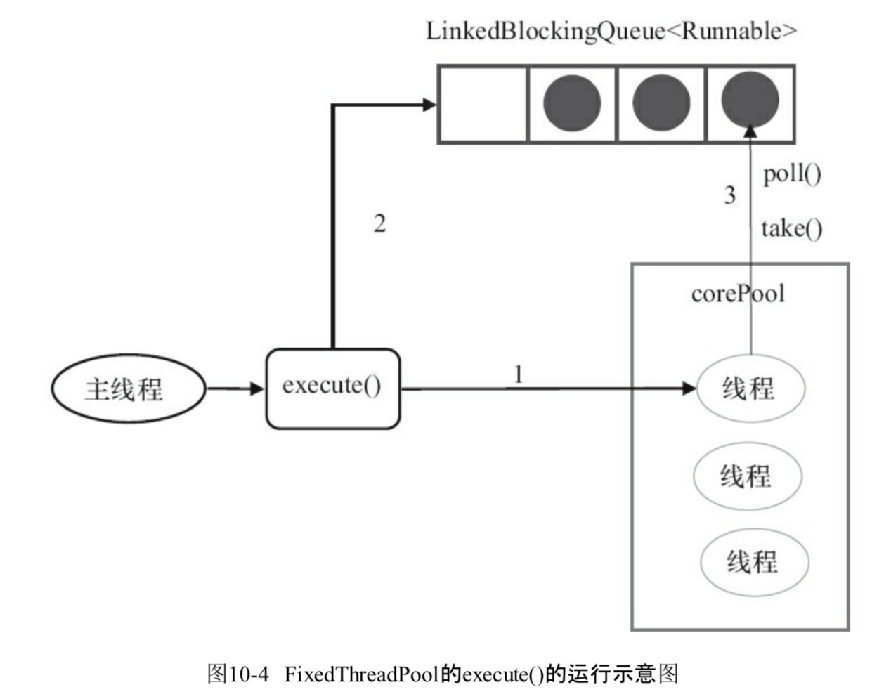

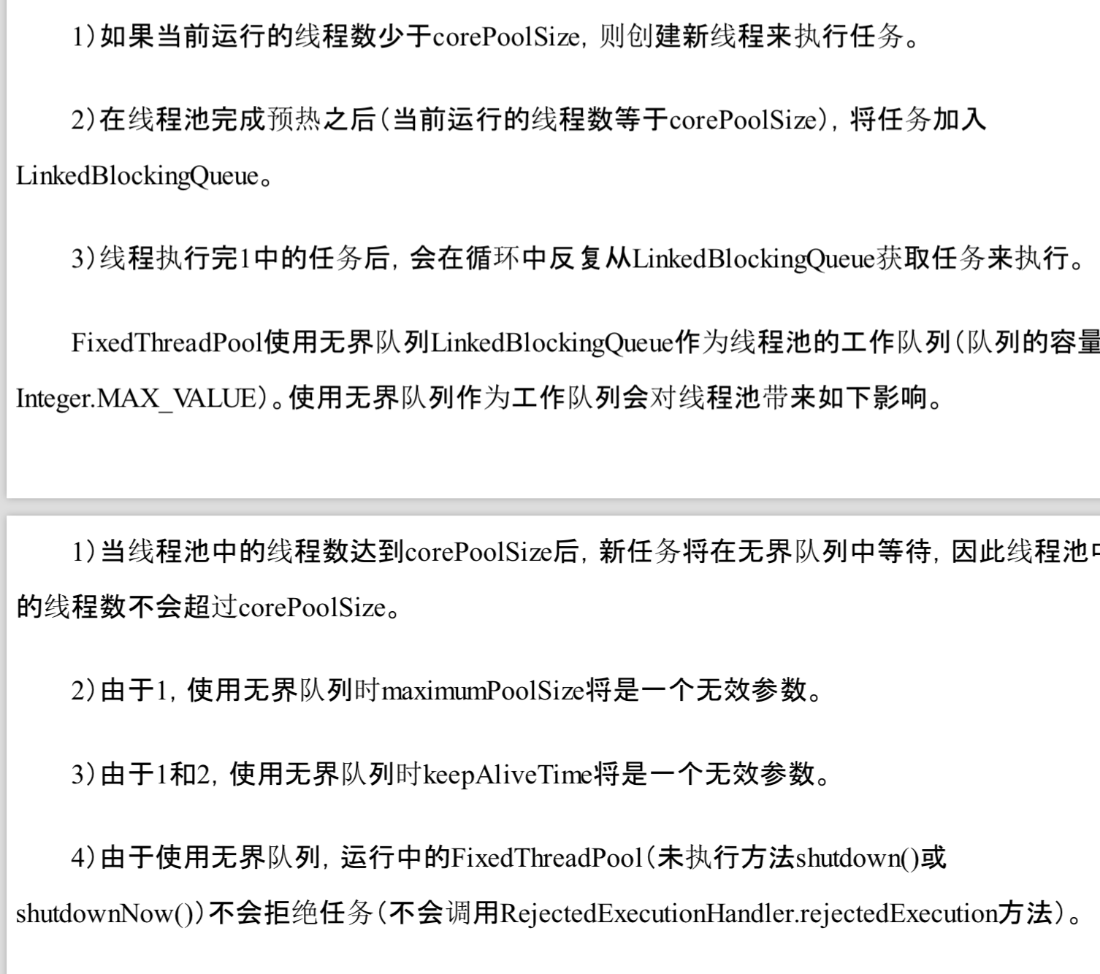

### 10.2.2 SingleThreadPool详解

SingleThreadExecutor是使用单个worker线程的Executor。

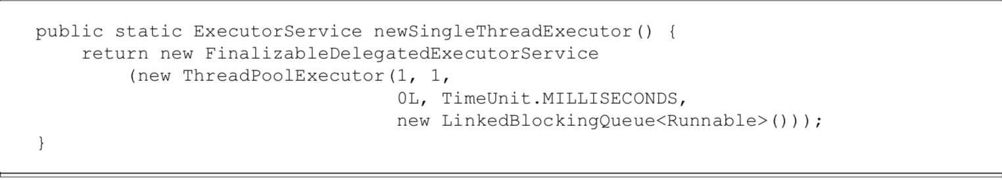

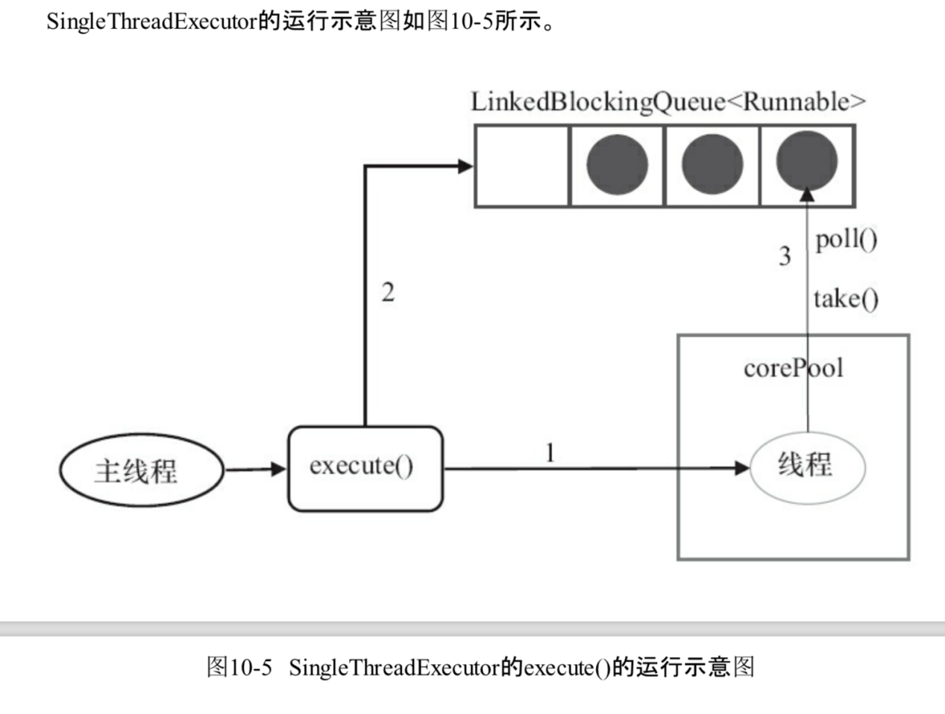

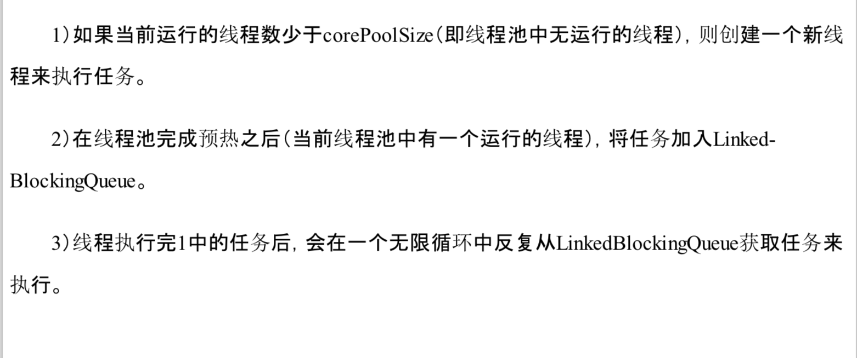

### 10.2.3 CachedThreadPool详解

CacheThreeadPool是一个会根据需要创建新线程的线程池

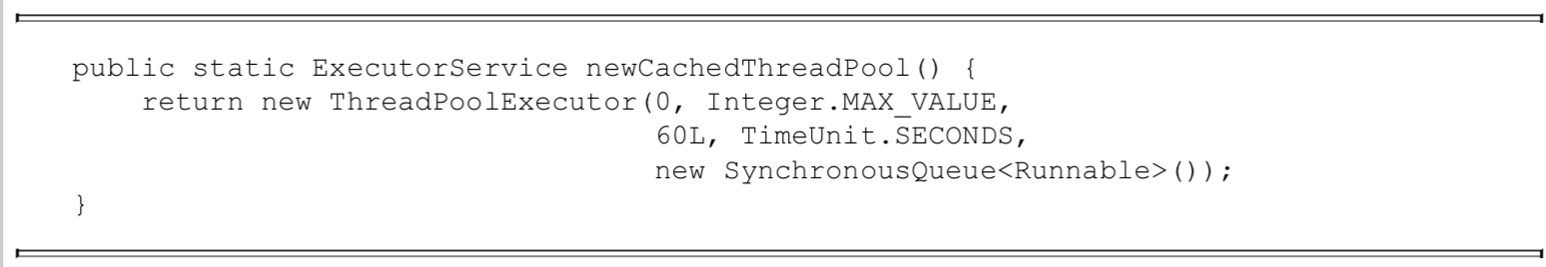

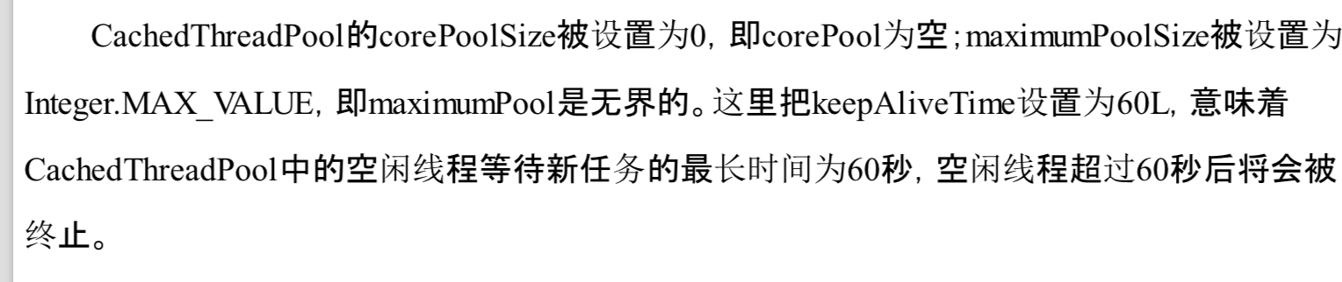

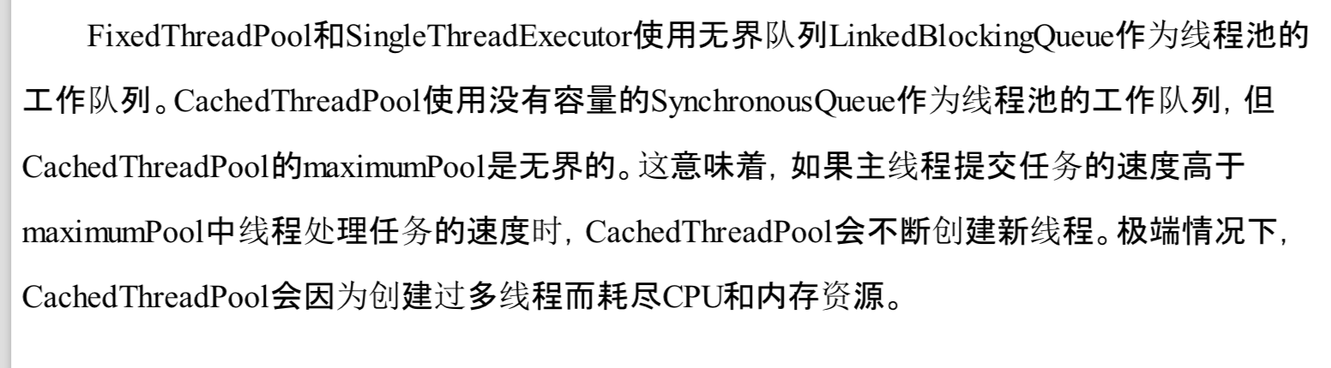

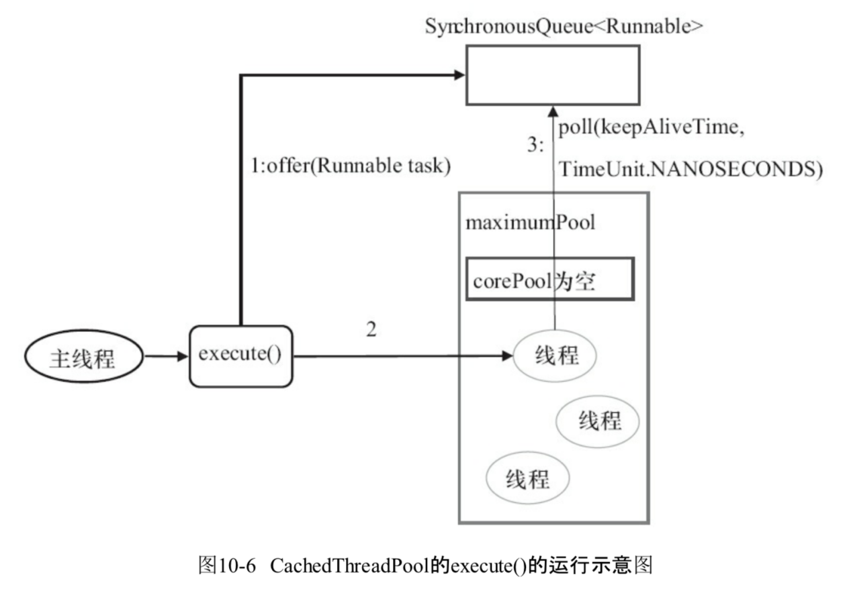

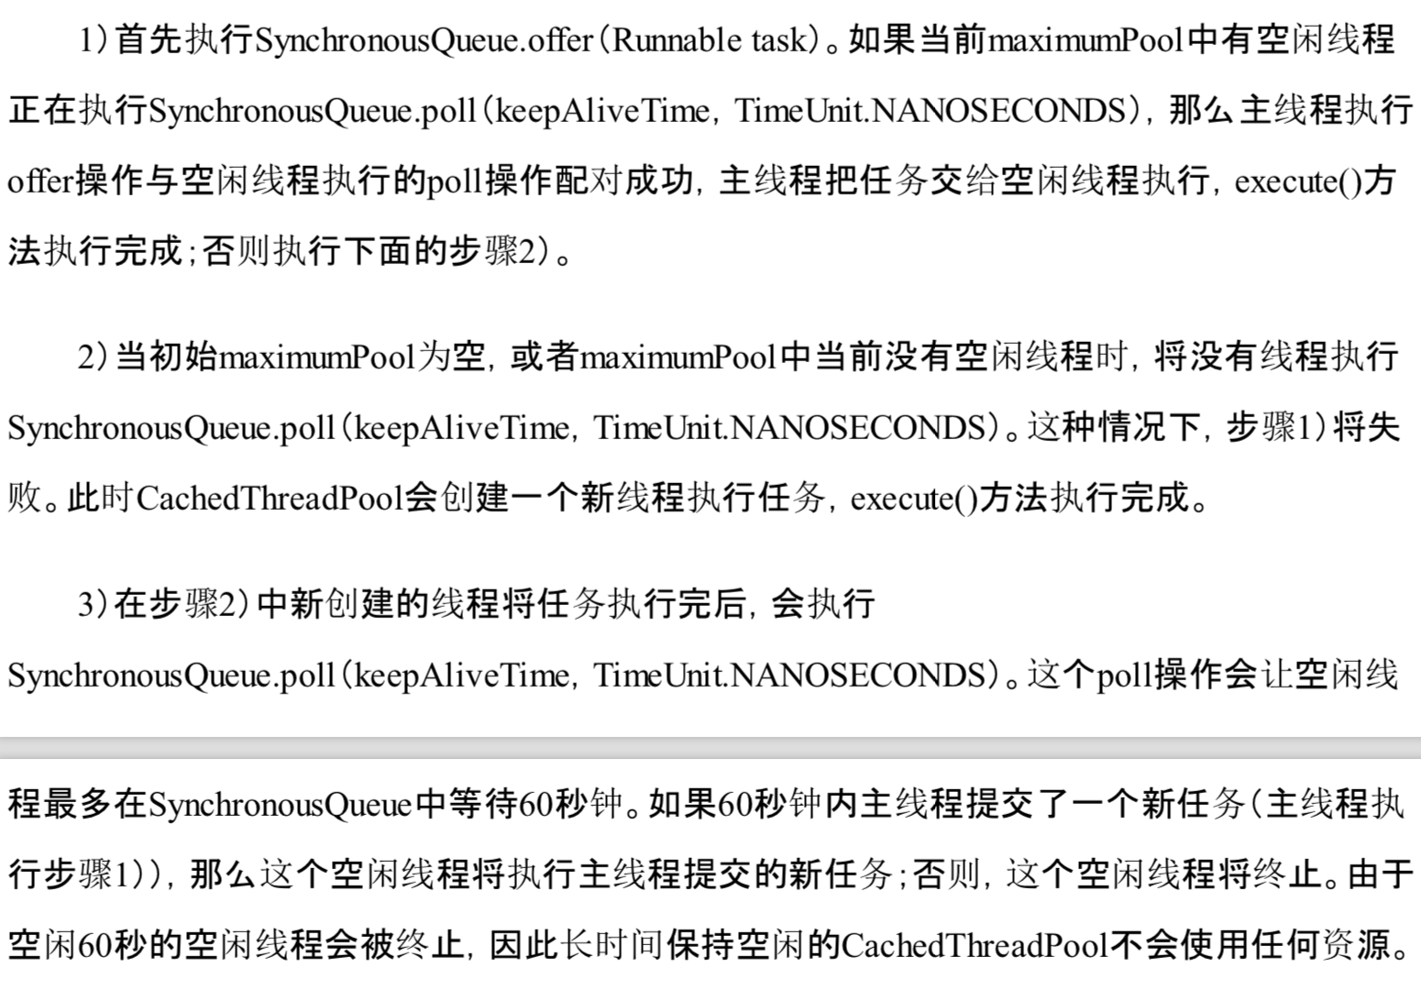

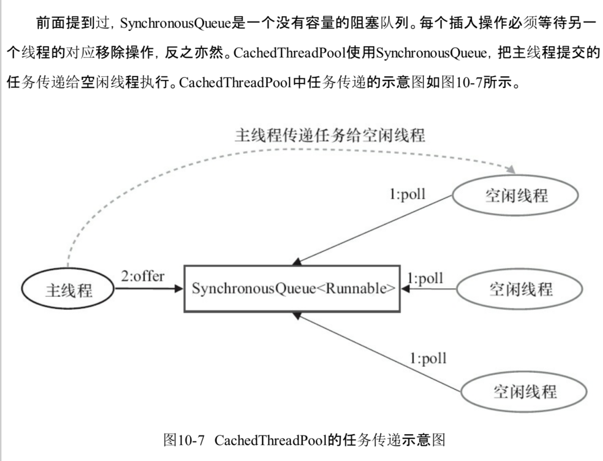

## 10.3 ScheduledThreadPoolExecutor详解

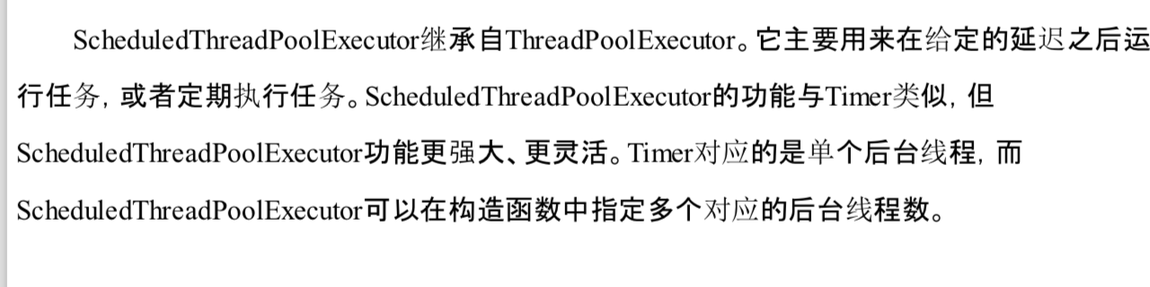

### 10.3.1 ScheduledThreadPoolExecutor的运行机制

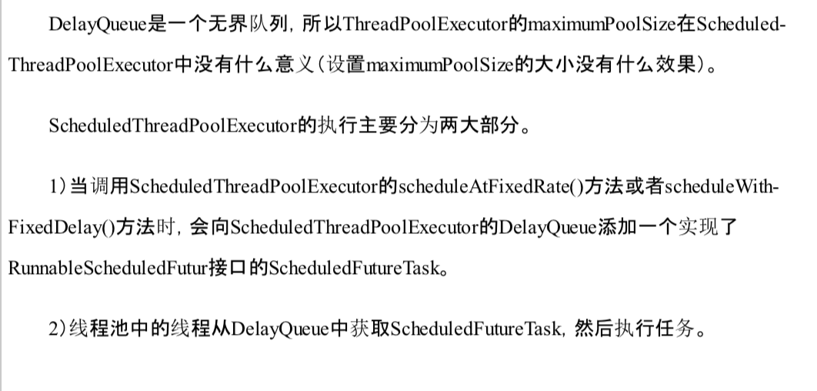

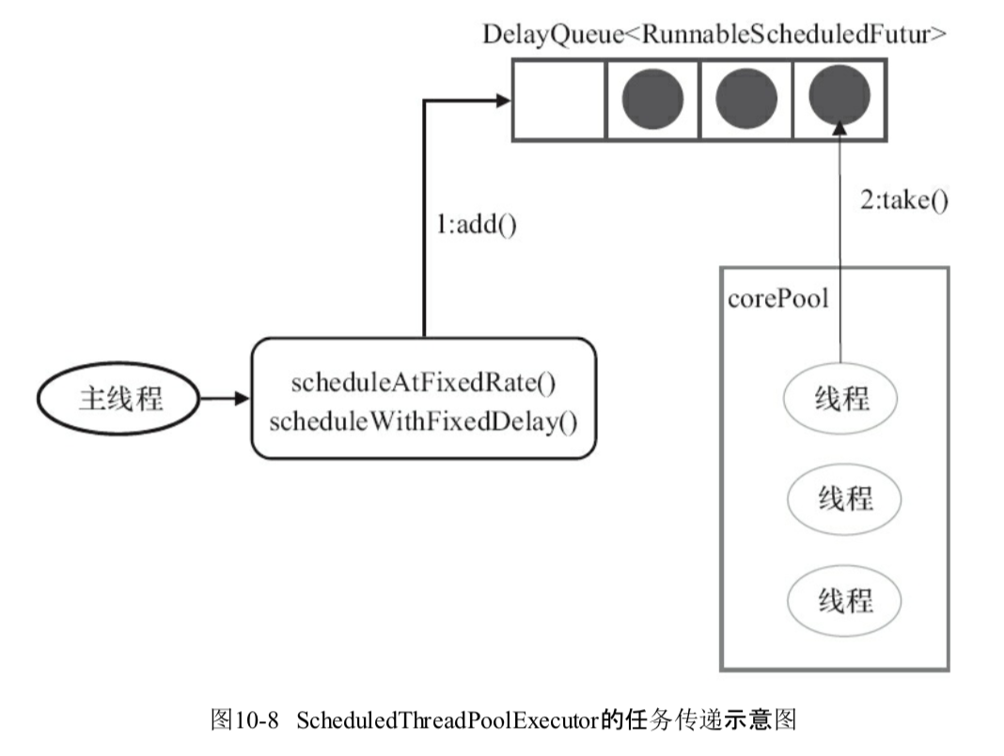

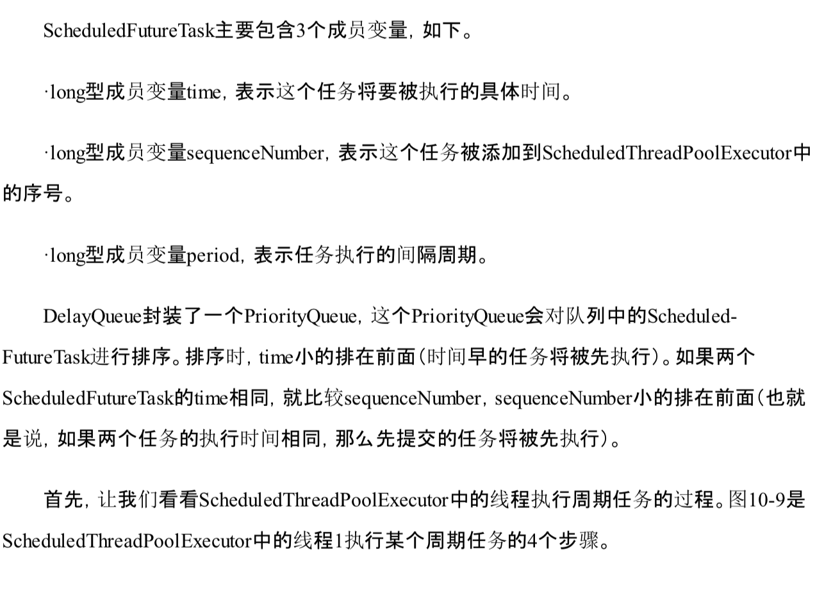

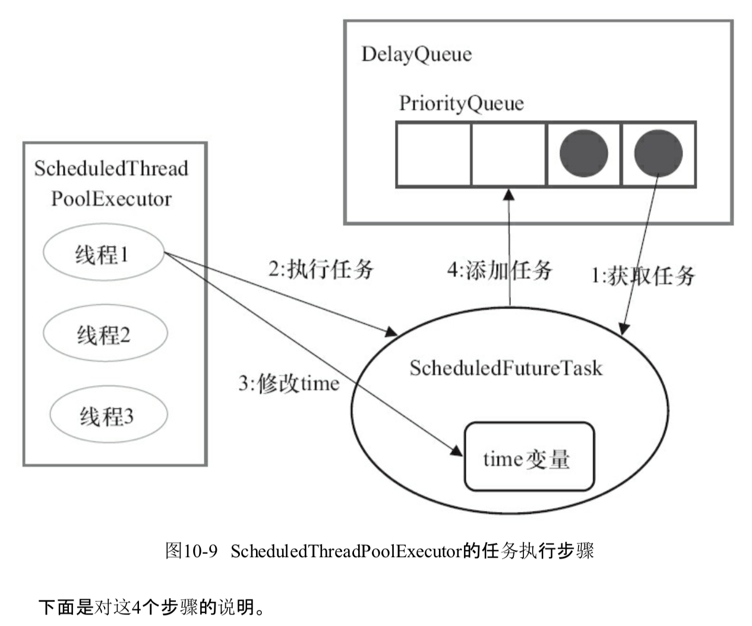

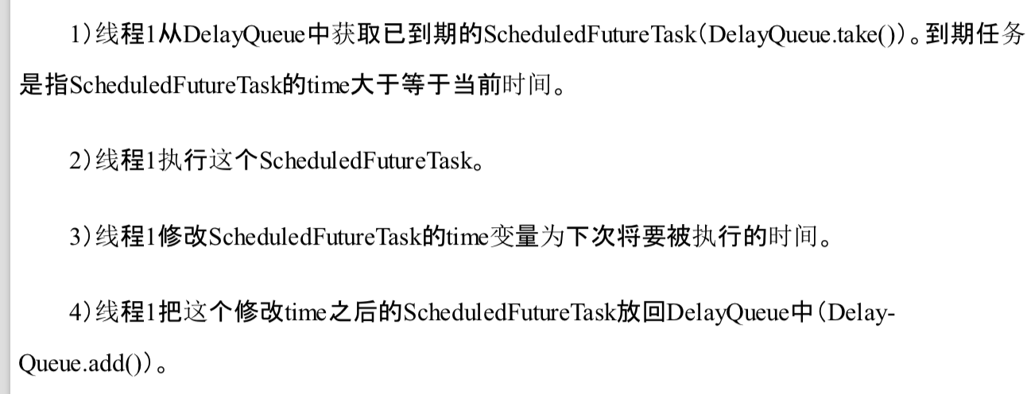

## 10.4 FutureTask详解

### 10.4.1 FutureTask简介

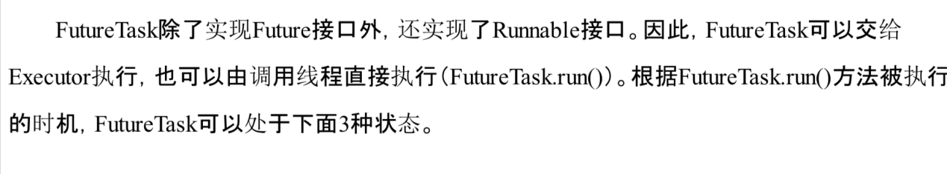

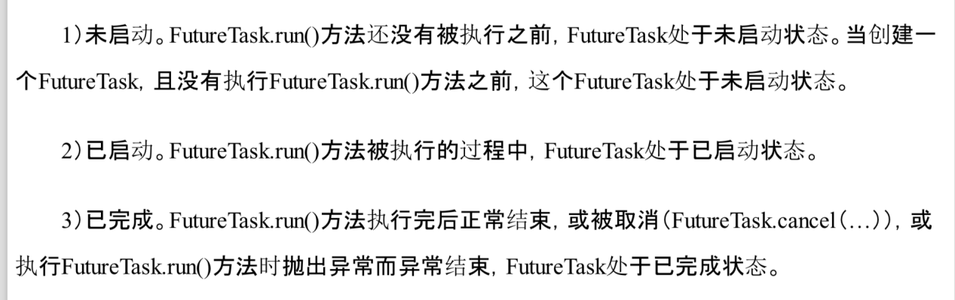

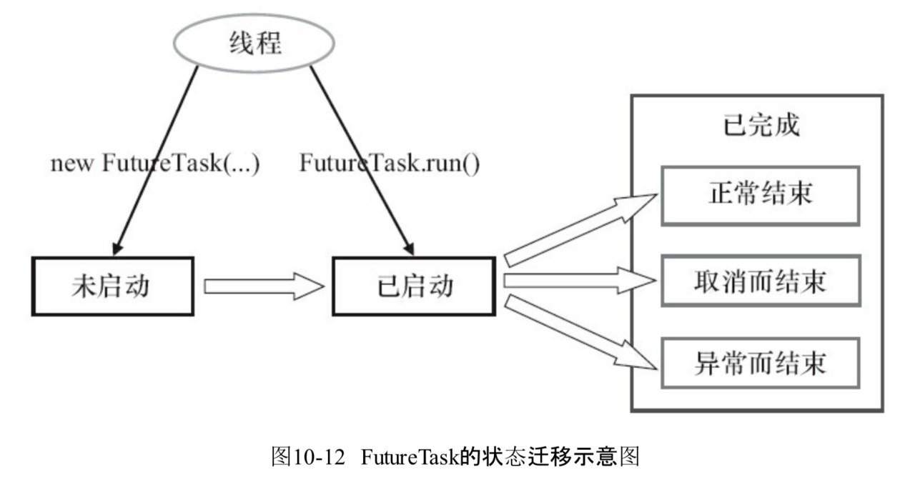

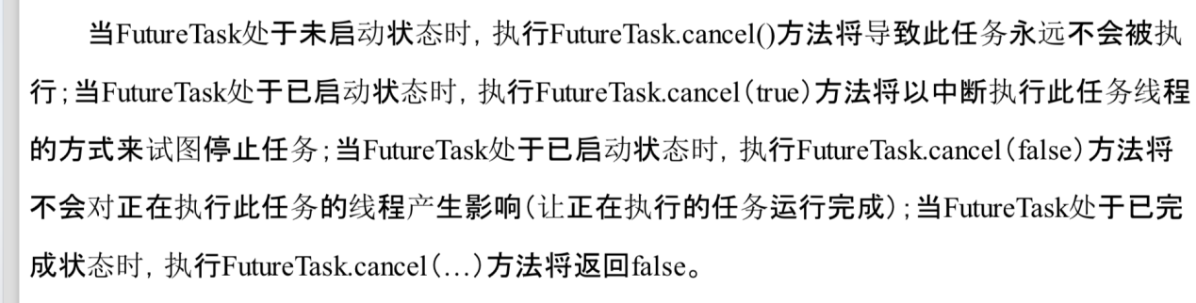

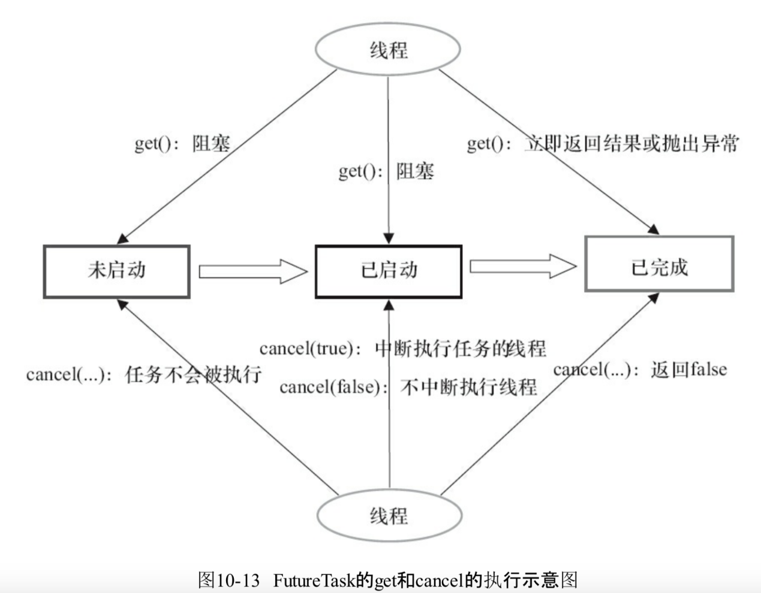

# Executor框架

# 扩展